Part 1. Read the passage given and write 3-4 sentences in this space supporting or denying the claim of this article. Indicate at least 3 reasons why or why not:

Part 2. IONIC BONDS Lab Purpose: The purpose of this lab is to illustrate that chemical compounds are electrically neutral and to show the ratio in which ions combine to form a chemical compound.
Pre-Lab: Finish the following statements in your own words:

- Compounds are electrically neutral because …….._______________________________________
- A cation and an anion will form a compound due to the ……_____________________________________
- You would expect Na+ to bond with Cl- to form a compound because ……..____________________________
- Polyatomic ions are ………_________________________________

Observations:
Combining Substance | Model | Chemical Formula | Electron Dot
1.aluminum & bromine

2.sodium & oxygen

3.potassium & chlorine

4.aluminum & nitrogen

5.calcium & chlorine

6.potassium & sulfur

7.Aluminum & hydroxide

8.Magnesium & phosphate

9.Calcium & Acetate

10.Zinc & sulfate

11. Potassium & carbonate

12. ammonium & hydroxide

13. aluminum & carbonate

14.Magnesium & nitrate

15.Ammonium & phosphate

16. Iron 2+ & carbonate

17. Iron3+ & nitrate

18.Copper (cuprous) & sulfate

19. Copper (cupric) and hydroxide

20.Aluminum & phosphate

Conclusion:
Name each compound in observation section#1-6. Name the metal first. Then name the nonmetal and change its ending to –ide. Example: sodium chloride
- _____________________ 3. ________________________ 5. _____________________

- _____________________ 4._________________________ 6. ______________________

Name each compound in # 7 -20 using the name of the metal ion first and then the name of the polyatomic ion second.

7. ______________________ 8. __________________________ 9. _____________________________

10. ______________________ 11. _________________________ 12. ____________________________

13. ______________________ 14. _________________________ 15. ___________________________

16. ____________________ 17. __________________________ 18. ___________________________

19. ____________________ 20. ___________________________
Define:
- A Negative ion is…… 2. A Positive ion is …….. 3. An Ionic bond is ……..

Post lab:
4. As I wrote the compounds chemical formulas in today’s lab, I notice that the ion charges _______________________

5. The number of atoms of elements that form compounds are in certain ratios because____________________________

Part 3. Flip chart naming:
  - Obtain the colored sheets of paper that have boxes of rules for naming various compounds.
  - Cut these out and place them in a “flip book “ fashion with the heading listed at the bottom of each flip chart to find the rules list needed.
  - Punch a hole with a one hole puncher in the upper left hand corner and tie a piece of string or fashion a ring with a paper clip to hold it together.
  - Use these rules throughout the process of us learning to name and write chemical formulas.
  - This flip chart will not be available for use on tests and quizzes only during practice and class activities.
  - If you use it now you will not need it by the time the test rolls around!
Part 4. Create a shape Activity:
  - Obtain the two pages of shapes. One page will have all squares and the other page will have all diamonds. Both shapes will have names and / or chemical formulas written on them.
  - Cut out all of the shapes and position them to match their corresponding name or formula partner. Ex NaCl / Sodium Chloride.
  - Once you have determined the one shape that you have created from all of the pieces ( it should be obvious if you did this correctly, it will be a shape you will recognize) glue the pieces down onto a piece of colorful construction paper. ( I have extra in the student center if you need it)
  - Cut out the edges of the construction paper around the shape. Write your name on the back of the shape on the construction paper.
  - Decorate the shape appropriately to be displayed in the classroom.
  - Make sure that your decorations do not cover the words and formulas on the page.
Part 5. Writing Chemical Formulas Form the following compounds
Elements | Ions & Valence # | Final Formula
K and Br | K Br | KBr
Ca and P

Al and F

Mg and OH

Ba and O

Li and S

Li and F

Na and Cl

Ba and PO₄

Be and I

Potassium and nitrogen

Aluminum and chlorate

Zinc and sulfate

Aluminum and hydroxide

Zinc and sulfite

Sodium and chlorine

Strontium and bromine

Potassium and iodine

Lithium and carbonate

Magnesium and phosphorus

Part 6. Polyatomic Compounds Name these Polyatomic ions:
Ion with charge | Name
(OH) ^{–1}
(SO₄) ^{–2}
(SO₃) ^{–2}
(PO₄) ^{–3}
(NO₃) ^{–1}
(NO₂) ^{–1}
(CO₃) ^{–2}
(C₂H₃O₂) ⁻¹
(ClO₃) ^{–1}
(NH₄) ⁻¹
Fill in the blanks / Identify.
- A variable valenced element has greater than _________(amount) possible valences listed across from it on the back of our periodic tables.
- A nonvariable valenced element always acts with only _____(amount) possible valence number.
3. Identify the following as variable (V) or nonvariable (NV) elements:
Aluminum _________ Tin _________ Nickel_________ Cobalt _________ Magnesium _________
Manganese _________ Gold _________ Iron _________
4. A binary compound consists of _________________ elements and has _________________capital letters.
- A _________________compound consists of three or more different kinds of elements and has at least _________________capital letters.
- Identify the following as binary (B) or polyatomic (P) compounds
1. KBr 2. Fe₃P₂ 3. Ki₂S 4. SnF₂
5. SnF₂ 6. LiF 7. Mg(OH)₂ 8. Ba₃(PO₄)₂
7. . A chemical formula which elements are present in a compound with a _________________. It shows how many atoms of each element is present with a _________________.
8. A subscript number of _________________ is never written in the chemical formula.
9.The number of atoms of each element inside the parenthesis is _________________ by the number outside the parenthesis to find out how many atoms of each atom is in a formula.
10. The _________________(metal) ion is always written first.
11. The _________________(nonmetal) ion is always written last.
12. Circle which one of the following elements comes first in a compound:
hydrogen, chlorine manganese, nitrate sodium, oxygen lithium, hydroxide bromine, calcium
hydroxide, ammonium barium, carbonate sulfate, iron

Part 7: Naming and Formula Writing for Binary Ionic Compounds: Give correct names for these binary ionic compounds
Formula Name Formula Name
KCl |  | MgO
K₂O |  | AlCl₃
CaO |  | BaS
MgCl₂ |  | Al₂S₃
NaH |  | SrF₂
ZnS |  | MgI₂
RbBr |  | CaSe
Al₂O₃ |  | BaBr₂
Na₃N |  | CsCl
Ca₂C |  | Mg₃P₂
KI |  | CaCl₂
Part 8 Give correct formulas for these binary ionic compounds
Name Ions Formula Name Ions Formula
Calcium iodide |  | Magnesium phosphide
Calcium hydride |  | Sodium chloride
Magnesium fluoride |  | Barium oxide
Cadmium bromide |  | Aluminum arsenide
Sodium nitride |  | Calcium sulfide
Rubidium oxide |  | Potassium selenide
Barium nitride |  | Sodium iodide
Lithium chloride |  | Lithium sulfide
Silver sulfide |  | Calcium carbide
Aluminum nitride |  | Sodium hydride
Cesium fluoride |  | Magnesium nitride

Part 9:. Which 3 transition elements are NOT variable and should NOT use Roman numerals?
___________________, ________________________, ___________________
Part 10. Naming and Formula Writing for Variable and Transition Elements aka STOCK System
Write the names of each of the following compounds:
Formula Name Formula Name
CuF |  | CrO₃
CuF₂ |  | AuBr
Cr₂O₃ |  | NiO
PbI₂ |  | VI₃
PbCl₄ |  | SnO₂

Part 11. Write the chemical formula for each of the given names:
Manganese (VII) oxide |  | Osmium (III) oxide
Nobium (V) chloride |  | Iridium (IV) nitride
Titanium (III) phosphide |  | Cobalt (II) chloride
Palladium (IV) sulfide |  | Iron (III) sulfide
Platinum (II) fluoride |  | Gold (III) iodide

Part 12. Cumulative Practice for Binary Ionic Compounds (Variable and non-variable)
I determine which compounds need a roman numeral by ______________________________________.
Name each of the following compounds….
FeCl₂ |  | AuP
Cu₂O |  | Mn₃P₄
CrCl₆ |  | Bi₂O₃
BiBr₃ |  | ZnCl₂
CoCl₂ |  | PbO
Fe₃N₂ |  | CrBr₃
AgCl |  | Au₂S₃
Bi₂S₃ |  | Sn₃P₄
CrP |  | Fe₂S₃
Co₂S₃ |  | CoBr₃
Na₂S |  | Al₂O₃
Au₃N |  | PbCl₄
BiBr₅ |  | CrF₆
MgCl₂ |  | NaCl
RbI |  | Fe₃P₂
SnF₂ |  | CrCl₃
BiF₅ |  | BN
Part 13. Naming and Formula Writing for Compounds containing Polyatomic Ions…
Al₂(SO₄)₃ |  | Na₃PO₄
CaSO₄ |  | Li₂SO₄
Zn₃(PO₄)₂ |  | BaSO₃
Sr(NO₂)₂ |  | LiNO₂
Al(NO₃)₃ |  | Ag₂CO₃
Ca(OH)₂ |  | Zn(NO₃)₂
BeCO₃ |  | Sr(OH)₂
Al(ClO₃)₃ |  | Be₃(PO₄)₂
NaC₂H₃O₂ |  | Ca(OH)₂
NH₄Cl |  | Ni(C₂H₃O₂)₂
ZnSO₄ |  | Ag₂CO₃
Li₂CO₃ |  | Ca(NO₂)₂
Sr(ClO₃)₂ |  | Sr(C₂H₃O₂)₂
Zn(OH)₂ |  | Ba₃(PO₄)₂
Al(NO₃)₃ |  | NH₄OH
Be₃(PO₄)₂ |  | AlPO₄
Part 14 Polyatomic Naming and Formula Writing….
Bismuth (III) sulfate |  | Silver carbonate
Zinc sulfate |  | Mercury (II) nitrite
Cobalt (III) carbonate |  | Strontium acetate
Iron (III) chlorate |  | Manganese(IV) hydroxide
Aluminum nitrate |  | Barium phosphate
Gold (I) nitrate |  | Gold (I) carbonate
Beryllium phosphate |  | Sodium phosphate
Mercury (I) carbonate |  | Chromium (VI) phosphate
Iron (II) sulfite |  | Lithium nitrite
Ammonium carbonate |  | Bismuth (V) carbonate
Mercury (II) nitrate |  | Calcium nitrite
Aluminum chlorate |  | Barium phosphate
Cobalt (III) chlorate |  | Copper (I) chlorate
Calcium hydroxide |  | Lead (II) sulfite
Sodium acetate |  | Zinc sulfite
Part 15 Formula Writing and Naming for Covalent Compounds
SO₃ |  | P₄S₅
N₂S |  | SeF₆
PCl₃ |  | Si₂Br₆
BF₃ |  | SCl₄
P₂Br₄ |  | NF₃
CO |  | Cl₂O₇
SiO₂ |  | N₂O₅
SF₆ |  | P₂Cl₃
NH₃ |  | FI₃
NO₂ |  | CBr₂
Dinitrogen Tetrahydride |  | Carbon disulfide
Carbon Tetrachloride |  | Nitrogen monoxide
Diphosphorus Trioxide |  | Diboron tetrahydride
Dichlorine Heptoxide |  | Sulfur dibromide
Carbon dioxide |  | Tetraphsphorus decoxide
Hexaboron silicide |  | Phosphorus pentachloride
Chlorine dioxide |  | sulfur trioxide
Iodine pentafluoride |  | Carbon dioxide
Dinitrogen trioxide |  | Dinitrogen pentoxide
Phosphorous triiodide |  | Sulfur hexafluoride

Part 16. Naming and Formula Writing for Acids…(“what I ate was icky and don’t bite its infectious!”)
HCl |  | H₂C₂O₄
HNO₃ |  | H₂CO₃
H₂SO₃ |  | H₃PO₄
HClO |  | HC₂H₃O₂
HClO₂ |  | HBrO₃
HClO₃ |  | H₃BO₃
HClO₄ |  | HCN
HBr |  | H₂Cr₂O₇
H₂SO₄ |  | HF
HMnO₄ |  | H₂S
Nitrous acid |  | Acetic acid
Chromic acid |  | Hydrlofluoric acid
Sulfuric acid |  | Nitric acid
Phosphoric acid |  | Chloric acid
Hydroiodic acid |  | Chlorous acid
Carbonic acid |  | Perchloric acid
Part 17. Cumulative Naming and Formula Writing Review…
Al₃O₂ |  | Be(OH)₂
Pb(NO₃)₂ |  | Cu₂S
CaO |  | AgCl
HBr |  | Pb₃(PO₄)₂
CCl₄ |  | FeSO₄
N₂O₅ |  | SiO₂
H₂SO₄ |  | N₂S
NaCl |  | NO₂
SF₆ |  | SO₃
Li₂S |  | KMnO₄
Carbon monosulfide |  | Tin (IV) sulfide
Vanadium (II) phosphide |  | Silver nitrate
Oxygen difluoride |  | Bromic acid
Hydrochloric acid |  | Titanium (IV) oxide
Gold (I) phosphate |  | Zinc chloride
Aluminum carbonate |  | Antimony(V) bromide
Dinitrogen heptoxide |  | Chlorous acid
Cobalt (II) acetate |  | Ammonium chloride
Ammonium cyanide |  | Aluminum nitride
Triboron tetrahydride |  | Cadmium nitrate

Part 18. Bubble Gum Loss
Objective: To determine the percent composition of sugar in bubble gum by chewing the gum, using electronic balances and calculations of percentages

Before Chewing:
Average mass of gum + wrapper ___________
Average mass of gum wrapper ____________
Average mass of one piece of bubble gum _____________
After Chewing:
Total mass of bubble gum and wrapper _____________
Average mass of one piece of chewed bubble gum __________

Analysis:
Average mass of sweetener in one piece of gum. _____________________
Percentage of sweetener and flavoring in gum.
Total mass of sweetener / total mass of gum x 100 = %
_____________________ x 100% = __________________

Part 19 Lab HYDRATE OF A SALT
Data
 |  |  | label
 | crucible and cover | _______________ | _____
 | crucible, cover, and hydrated salt | _______________ | _____
 | crucible, cover, and anhydrous salt (lowest) | _______________ | _____
 | filter paper | _______________ | _____
 | filter paper and precipitate | _______________ | _____

Analysis
 |  |  | Label
1. | mass of hydrated salt | _______________ | _____
2. | mass of anhydrous salt | _______________ | _____
3. | mass of water lost | _______________ | _____
4. | moles of water in original sample | _______________ | _____
5. | mass of silver (I) chloride precipitated | _______________ | _____
6. | moles of silver (I) chloride | _______________ | _____
7. | moles of chloride ion present | _______________ | _____
8. | mass of chloride ion present | _______________ | _____
9. | mass of barium in original sample | _______________ | _____
10. | moles of barium in original sample | _______________ | _____

Conclusions
1. Relative actual number of moles for hydrated salt: Ba: ________ Cl: ________ H₂0: ________
2. Lowest whole number ratio for hydrated salt: Ba: ________ Cl: ________ H₂0: ________:
3. Empirical formula for hydrated salt:
Ba |  | Cl |  | •_______ | H₂O
 | _______ |  | _______

4. What is the proper name for this compound?
5. The formula mass of this compound is _______________. (Show your work.)
6. There were __________ moles of this compound present when you started. (Show your work.)
Part 20. Empirical Formula: Practice:
1. A compound was found to have 63.52 % iron and 36.48 % Sulfur. What is the empirical formula?

2. Find the empirical formula of a compound that has 26.56% potassium, 35.41% chromium, and the remainder Oxygen?

3. Analysis of 20.0 g of a compound containing only calcium and bromine indicates that 4.00 g of calcium are present. What is the empirical formula of the compound?

Part 21. Molecular Formula: x = molecular formula mass
Empirical formula mass
(Empirical formula)x = molecular formula
1. The empirical formula of a compound of phosphorus and oxygen was found to be P₂O₅. Experimentation shows the molar mass of this compound was 283.89 g / mol. What is the compounds molecular formula?

2. Determine the molecular formula of the compound with an empirical formula of CH and a formula mass of 78.11 g

3. A sample of a compound with a formula mass of 34.00 g is found to consist of 0.44 g of H and 6.92 g O. Find the molecular formula.

HMK: Page 233 # 1-5(solve these problems in your spiral notebook

Part 22. MOLE AIRLINES Project

This project was given to me on (date) _________________ and will be due on (date) _________________

It will be worth 2 daily grades. I ,________________________certify that I worked completely independently on this project and did not copy results from any other students. I understand that this project is due on the date listed above at the beginning of the class period. I also understand that a _________ point deduction will be given if turned in one day late and a ______________ point deduction will be given if turned in two days late. I also understand that all work must be shown in the format listed below to receive full credit.

MOLE- Airlines Sample problem: MOLE AIRLINES PROJECT
C= 37.01% H= 2.22% N= 18.5 % O= 42.27%

2.33 x 3 = 7
C = 3.08 = 2.33
1.32
C = 37.01g X 1 mole C = 3.08 moles
12.0111g C
1.67 x 3 = 5
H = 2.20 = 1.67
1.32
H = 2.22g X 1 mole H = 2.20 moles
1.007g H
1.00 x 3 = 3
N = 1.32 = 1.00
1.32
N = 18.5g X 1 mole N = 1.32 moles
14.0167g N

2.00 x 3 = 6
O = 2.64 = 2.00
1.32

O = 42.27g X 1 mole O = 2.64 moles
15.9980g O

7 5 3 6

Victims Name C₇H₅N₃O₆ trinitrotoluene explosive

You will receive your Mole Airlines project 1 week before it is due
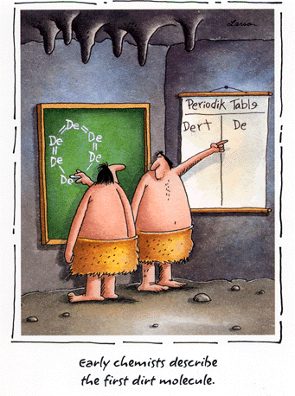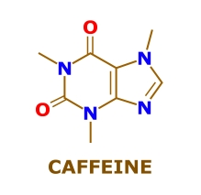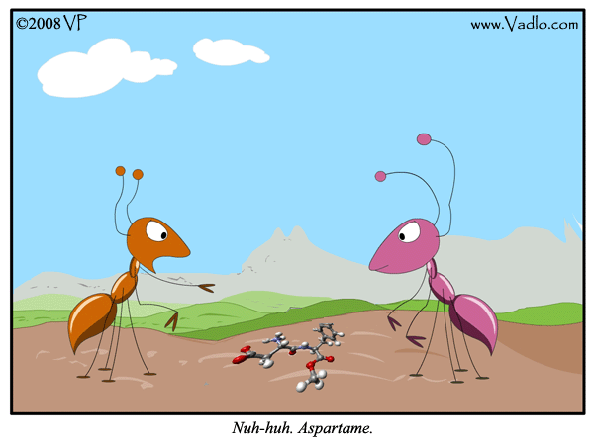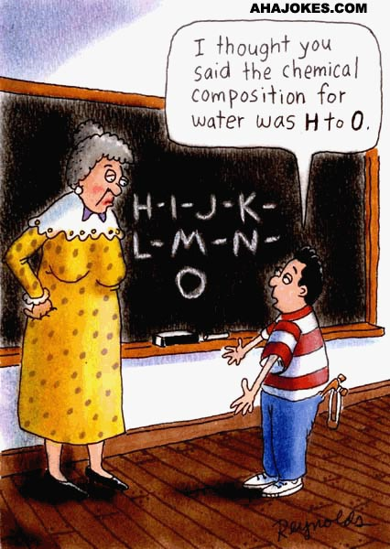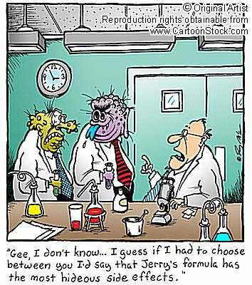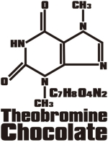
Name __________________________________

Date ____________________

Period __________
If found please return to J204 Mrs. Paul

Chemical Formulas

