Electromagnetic Spectrum Activity DO NOT WRITE ON THIS SHEET! CLASS SET # _____________
Directions: Read each of the sections below and answer the questions. Show all work for calculations. You will need to use your notes on EM spectrum for this activity.

Part 1 Waves in the EM Spectrum. Copy the 5 step method grid in your spiral for each calculation.
Given | Formula | Plug in | Answer | Unit
v = frequency (number of waves per sec)= ___________ Hertz/sec  c = speed of light = 3 x 10⁸ meter/sec  λ = wavelength = ___________meters | v= c  λ

- Calculate the frequency of waves for a radio wave that has a wavelength of 300 m?
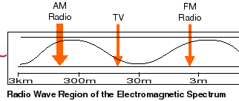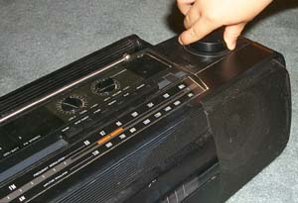 | Radio waves have the longest wavelengths in the electromagnetic spectrum. These waves can be longer than a football field or as short as a football. Radio waves do more than just bring music to your radio. They also carry signals for your television and cellular phones.

- Calculate the frequency of waves for a microwave that has a wavelength of 0.30 m?
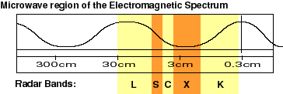 | Microwaves have wavelengths that can be measured in centimeters! The longer microwaves, those closer to a foot in length, are the waves which heat our food in a microwave oven.

C. Calculate the frequency for each color of wavelength, for the elements below Lithium, Calcium, Sodium, Barium and Copper.
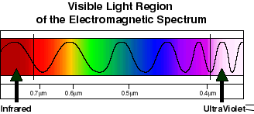  Visible light waves are the only electromagnetic waves we can see. | 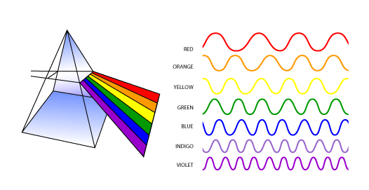  We see these waves as the colors of the rainbow. | 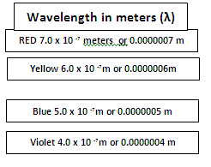 Each color has a different wavelength. Red has the longest wavelength and violet has the shortest wavelength. When all the waves are seen together, they make white light.
Color of Fireworks | Element’s Electrons Making the Color | Wavelength (m)
 | lithium =red strontium = bright red | 6.52 x 10 ⁻⁷ or 0.0000652
 | calcium = orange | 6. 68 x 10 ⁻⁷ or 0.0000668
 | sodium = yellow | 6.10 x 10 ⁻⁷ or 0.0000610
 | Barium= green | 5.89 x 10 ⁻⁷ or 0.0000589
 | copper = blue / blue green | 5.35 x 10 ⁻⁷ or 0.0000535
 | mixture of strontium (red) and copper (blue) | 4.20 x 10 ⁻⁷ or 0.0000420
D. Calculate the frequency of waves for UV waves that bees see if the wavelength is 3.0 x 10 ⁻⁷ m
  UVB = 3.20 x 10 ⁻⁷ m  UVA = 4.0 x 10 ⁻⁷ m  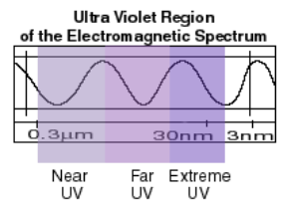  Wavelength of UV seen by Bees = 3.0 x 10 ⁻⁷ m | Ultraviolet (UV) light has shorter wavelengths than visible light. Though these waves are invisible to the human eye, some insects, like bumblebees, can see them!

E. Calculate the frequency of waves for a dental X-ray if its wavelength is 3.0 x 10 ⁻¹⁰ m?
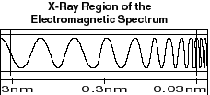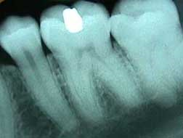 | When you get an X-ray taken at a hospital, X-ray sensitive film is put on one side of your body, and X-rays are shot through you. At a dentist, the film is put inside your mouth, on one side of your teeth, and X-rays are shot through your jaw, just like in this picture. It doesn't hurt at all - you can't feel X-rays. Because your bones and teeth are dense and absorb more X-rays then your skin does, silhouettes of your bones or teeth are left on the X-ray film while your skin appears transparent. Metal absorbs even more X-rays - can you see the filling in the image of the tooth?

F. Calculate the frequency of waves for an atomic bomb emitting gamma rays if the wavelength is 1.0 x 10 ⁻¹¹ m
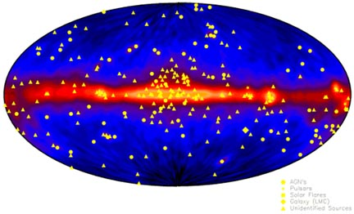 | Gamma-rays have the smallest wavelengths and the most energy of any other wave in the electromagnetic spectrum. These waves are generated by radioactive atoms and in nuclear explosions. Gamma-rays can kill living cells, a fact which medicine uses to its advantage, using gamma-rays to kill cancerous cells.  Gamma-rays travel to us across vast distances of the universe, only to be absorbed by the Earth's atmosphere.  Gamma-ray bursts can release more energy in 10 seconds than the Sun will emit in its entire 10 billion-year lifetime! So far, it appears that all of the bursts we have observed have come from outside the Milky Way Galaxy.
Part II: Using the frequencies (v) you calculated in Part 1, calculate and compare the Energies (E) of each. Copy the 5 step method grid seen below for each problem in your spiral.
Given | Formula | Plug In | Answer | Unit
E = energy =________ Joules  h = Planck’s constant = 6.626 x 10 ⁻³⁴ J . s  v = frequency = _______(Hertz / sec) | E = hv
- Energy of radiowaves ________________
- Energy of microwaves ________________
- Energy of Visible Light (Lithium red) ______________, (Calcium orange) ____________ (Sodium yellow) _______________ (Barium green) ________________ (Copper blue) _____________
- Energy of UV _______________________________
- Energy of Xrays _________________________
- Energy of Gamma rays ___________________________

