Name ____________________________________ Date ______ _____Estimated TEST DATE _______________________
Period _____ IF found, please return to J204 Mrs. Paul
Gas Laws : Honors Chemistry

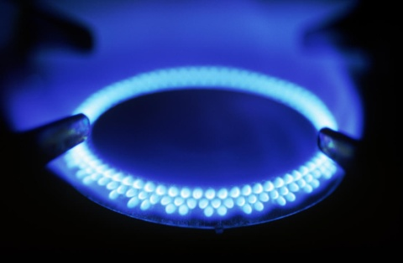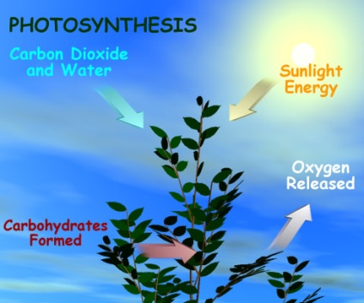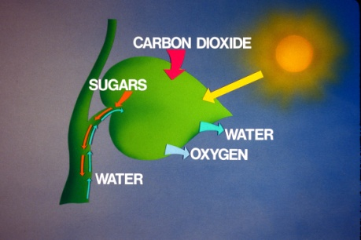
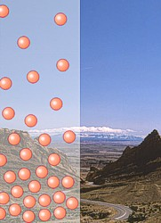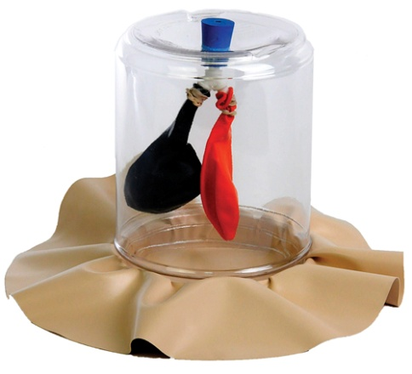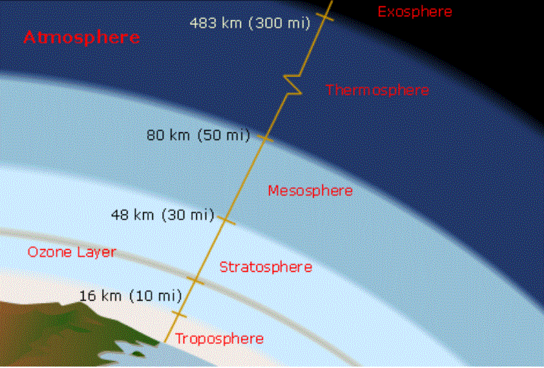
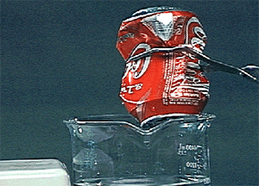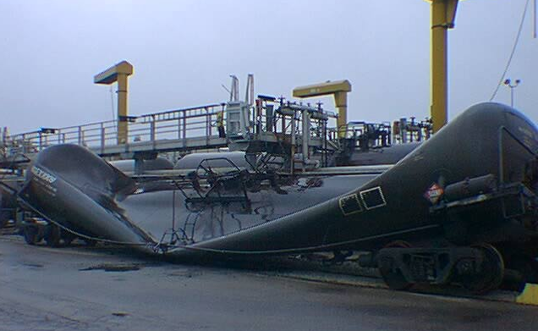
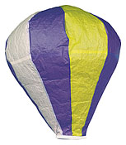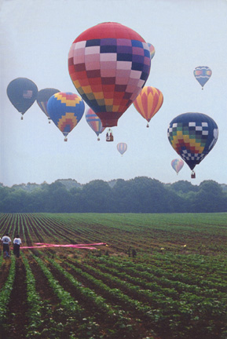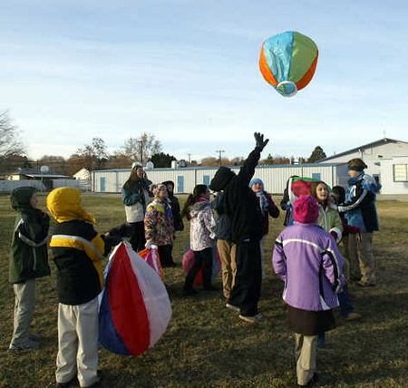
Avogadro’s Law Gas Conversions Solve the following, assuming the conditions remain at STP for each question.
Dimensional Analysis work here:
- 15.86 g CO₂ = ______________ L CO₂
- 1.86 mol N₂ = ______________ L N₂
- 385 L NO₂ = ______________ g NO₂
- 86.7 mol He = ______________ g He
- 29.3 mol CO = ______________ L CO
- 50.1 L CH₄ = ______________ mol CH₄
- 79.4 g F₂ = ______________ L F₂
- 66.8 mol Cl₂ = _____________ g Cl₂
- 799 g SO₂ = ______________ L SO₂
- 22.3 L Ar = ______________mol Ar

Charles’ Law Problems
- A sample of neon gas occupies a volume of 752 ml at 25˚ C. What volume will the gas occupy at 50˚ C, with pressure remaining constant?
- A balloon filled with oxygen gas occupies a volume of 5.5 L at 25˚ C. What volume will the gas occupy at 100˚ C?
3. A sample of nitrogen gas is contained in a piston with a freely moving cylinder. At 0˚ C the volume of gas is 375ml. To what temperature must the gas be heated to occupy a volume of 500ml?
4. At standard temperature, a gas has a volume of 275ml. The temperature is then increased to 130˚ C, and the pressure is held constant. What is the new volume?
Gay Lussac’s Law
5. The gas in an aerosol can is at a pressure of 3.00 atm at 25˚C. Directions on the can warn the user not to keep the can in a place where the temperature exceeds 52˚C. What would gas pressure in the can be at 52˚ C?
6. A sample of hydrogen at 47˚ C exerts a pressure of 0.329atm. The gas is heated to 77˚ C at constant volume. What will its new pressure be?
7. To what temperature must a sample of nitrogen at 27˚ C and 0.625 atm be taken so that its pressure becomes 1.125 atm at constant volume?
8. The temperature within an automobile tire at the beginning of a long trip is 25˚C. At the conclusion of the trip, the tire has a pressure of 1.80 atm. What is the final temperature within the tire if its original pressure was 1.75 atm?
Combined Gas Law
9. A helium-filled balloon has a volume of 50.0 L at 25˚C and 1.08 atm. What volume will it have at 0.855 atm and 10˚ C?
10. A gas occupying 75 ml at standard conditions is heated to 17˚C while the pressure is reduced to 0.97 atm. What is the new volume occupied by the gas?
11. A sample of oxygen at 40˚ C occupies 820ml. If this sample later occupies 1250ml at 60˚ C and 1.40 atm, what was its original pressure?
12. A 350ml air sample collected at 35˚C has a pressure of 0.723 atm. What pressure will the air exert if it is allowed to expand to 425ml at 57˚C?
Mixed Problems:
1.A balloon is filled with 304 liters of helium at 1 atm, what is the volume when the balloon rises to an altitude where the pressure
Is 0.25 atm?
2. If a gas is compressed from 85 liters to 30 liters at 1 atm, assuming the temperature remains constant, what is the new pressure?
3. A gas with a volume of 8 liters at a pressure of 0.3 atm is allowed to expand until the pressure drops to 0.2 atm, what is the
new volume?
4. Ten liters of air at 55 degrees Celsius is warmed to 112 degrees Celsius. What is the new volume if the pressure remains constant?
5. A 6.0 L air sample at a temperature of 30 degrees Celsius has a pressure of 720 mm Hg. What will be the new pressure if the temperature is raised to 100 degrees Celsius and the volume expands to 9.0 L?
6. A helium filled balloon has a volume of 50.0 L at 25 ºC and 820 mmHg. What volume will it occupy at 650 mm Hg and 10 ºC.
7. If the pressure on a gas at –73 ºC is doubled but is volume is held constant, what will its final temperature be in degrees Celsius?
8. A sample of gas at 47 ºC and 780 mmHg pressure occupies a volume of 2.20 L. What volume would this gas occupy at 107oC and 600 mmHg?
9. A 350 mL air sample collected at 35 ºC gas a pressure of 550 mm Hg. What pressure will the air exert if it is allowed to expand to 425 ml at 57 ºC?
10. A gas measures 1.75 L at –23 ºC and 150kPa. At what temperature would the gas occupy 1.30 L at 210 kPa?

Select the term in Column B that matches the expression in Column A.
Column A Column B
1. pressure formula _____ a. 1 N/m²
2. millimeters of mercury _____ b. mm Hg
3. Pascal _____ c. force/area
4. 1 atmosphere _____ d. 760 mm Hg
5. STP _____ e. 1 atm, 0ºC

Use the conversion factors giving in your notes to convert the following pressures. Show grid set up.
Pressure in atm | Pressure in mm Hg | Pressure in kPa
6. 0.943
7. | 1345.21
8. |  | 79.64
9. | 1029.8
10. 0.546

Ideal Gas Law Practice Worksheet
Solve the following problems using the ideal gas law, remembering to convert all numbers to the appropriate units and show all work:
1) How many moles of gas does it take to occupy 120 liters at a pressure of 2.3 atmospheres and a temperature of 340 K?
- It is not safe to put aerosol canisters in a campfire, because the pressure inside the canisters gets very high and they can explode. If I have a 1.0 liter canister that holds 3.11 moles of gas, and the campfire temperature is 1400⁰ C, what is the pressure inside the canister?
- If I have a 50-liter container that holds 4.5 grams of nitrogen gas at a temperature of 200⁰ C, what is the pressure inside the container?
4) How many moles of O₂ gas are in a 30-liter scuba canister if the temperature of the canister is 300 K and the pressure is 200 atmospheres?
- A balloon can hold 100 liters of gas. If it is filled with 3 g of oxygen gas at a pressure of 1 atmosphere, what is the temperature of the balloon?
- At 28°C and 740 mm Hg pressure, carbon dioxide gas has a mass of 5.16g. What is the volume that this gas will occupy?
- When nitrogen gas occupies a volume of 125 mL at 20°C and has a mass of 0.427g. What is the pressure on this gas?
- Calculate the pressure exerted by 1.22 g of nitrogen dioxide confined to a flask of volume 500 mL at 37°C.

Gas Stoichiometry Practice
1. How many moles of gas are contained in 890.0 mL at 21.0 °C and 750.0 mm Hg pressure?
2. 1.09 g of H₂ is contained in a 2.00 L container at 20.0 °C. What is the pressure in this container in mm Hg?
3. Calculate the volume 3.00 moles of a gas will occupy at 24.0 °C and 762.4 mm Hg.
4. What volume will 20.0 g of Argon occupy at STP?
5. How many moles of gas would be present in a gas trapped within a 100.0 mL vessel at 25.0 °C at a pressure of 2.50 atmospheres?
6. How many moles of a gas would be present in a gas trapped within a 37.0 liter vessel at 80.00 °C at a pressure of 2.50 atm?
7. If the number of moles of a gas are doubled at the same temperature and pressure, will the volume increase or decrease?
8. What volume will 1.27 moles of helium gas occupy at STP?
9. At what pressure would 0.150 mole of nitrogen gas at 23.0 °C occupy 8.90 L?
10. What volume would 32.0 g of NO₂ gas occupy at 3.12 atm and 18.0 °C?
11. Find the volume of 2.40 mol of gas whose temperature is 50.0 °C and whose pressure is 2.00 atm.
12. Calculate the molecular weight of a gas if 35.44 g of the gas stored in a 7.50 L tank exerts a pressure of 60.0 atm at a constant temperature of 35.5 °C
13. How many moles of gas are contained in a 50.0 L cylinder at a pressure of 100.0 atm and a temperature of 35.0 °C?
14. Determine the number of moles of Krypton contained in a 3.25 liter gas tank at 5.80 atm and 25.5 °C. If the gas is Oxygen instead of Krypton, will the answer be the same? Why or why not?
15. Determine the number of grams of carbon dioxide in a 450.6 mL tank at 1.80 atm and minus 50.5 °C.
16. Determine the number of grams of oxygen that the same container will contain under the same temperature and pressure.
17. Determine the volume of occupied by 2.34 grams of carbon dioxide gas at STP.
18. A sample of argon gas at STP occupies 56.2 liters. Determine the number of moles of argon and the mass in the sample.
19. At what temperature will 0.654 moles of neon gas occupy 12.30 liters at 1.95 atmospheres?
20. A 30.6 g sample of gas occupies 22.4 L at STP. What is the molecular weight of this gas?
21. A 40.0 g gas sample occupies 11.2 L at STP. Find the molecular weight of this gas.
22. A 12.0 g sample of gas occupies 19.2 L at STP. What is the molecular weight of this gas?
23. 96.0 g. of a gas occupies 48.0 L at 700.0 mm Hg and 20.0 °C. What is its molecular weight?
24. 20.83 g. of a gas occupies 4.167 L at 79.97 kPa at 30.0 °C. What is its molecular weight?
25. At STP 3.00 liters of an unknown gas has a mass of 9.50 grams. Calculate its molar mass.
26. At STP 0.250 liter of an unknown gas has a mass of 1.00 gram. Calculate its molar mass.
27. At STP 150.0 mL of an unknown gas has a mass of 0.250 gram. Calculate its molar mass.
28. 1.089 g of a gas occupies 4.50 L at 20.5 °C and 0.890 atm. What is its molar mass?
29. 0.190 g of a gas occupies 250.0 mL at STP. What is its molar mass? What gas is it? Hint - calculate molar mass of the gas.
30. If 9.006 grams of a gas are enclosed in a 50.00 liter vessel at 273.15 K and 2.000 atmospheres of pressure, what is the molar mass of the gas? What gas is this?
31. What is the value of and units on R? What is R called ("A letter" is not the correct answer!)?
32. A 50.00 liter tank at minus 15.00 °C contains 14.00 grams of helium gas and 10.00 grams of nitrogen gas.

Charles law Lab
Equation of the Line__________________________Temperature at 0 mm _______________________

Length of air column (mm) | Temperature (ºC)

Questions:
- At what temperature does your extended graph line intersect the y-axis?
- What would be the volume of your gas sample at this temperature?
- Why is this volume only theoretical?
- Develop a new temperature scale based on your value for 0 volume, assigning the value zero to the temperature at which the graph intersects the y-axis. The new scale expresses temperature in Kelvin (K) – the Kelvin temperature scale. One Kelvin is the same size as one degree Celsius. However, unlike zero degrees Celsius, zero Kelvin is the lowest temperature theoretically possible – absolute zero. Based on your graph, what temperature in Kelvin would correspond to 0 ºC, the freezing point of water? What temperature would correspond to 100 ºC, the boiling point of water?

Boyles Law Lab
Background: The objective in today’s lab will be to investigate the relationship between volume and pressure of a gas. The gas we will use will be air. When the volume of a gas enclosed in a syringe is changed the pressure will vary inversely. It will be assumed that the temperature is constant. (Room temperature). The pressure and volume data will change
Purpose: to determine the relationship that exists between pressure and volume of a gas.

Procedure:
- Connect the GAS PRESSURE SENSOR probe to the LAB PRO interface as instructed by your teacher.
- Plug the pressure probe sensor into channel 1
- Open the valve on the syringe and draw up 10 mL of air (GAS) from the room.
- Close the valve on the syringe.
- Open the LOGGER PRO program on the computer
- Set up your pressure sensor for data collection: SET UP UNITS ATMCOLLECT DATAEvent s With Entry
- One person should operate the syringe and one person operates the calculator.
- Move the piston to the 5 ml mark and hold it steadily there and press the COLLECT sign to trigger data collection.
- ENTER VALUE = 5
- Repeat steps 8 and 9 for volumes of 7.5, 10.0, 12.5, 15.0, 17.5, 20.0ml.
- Select STOP and you will see the GRAPH of relationship of pressure and volume.
- Transfer data to your calculator from the computer or write it on your paper.
- Type the data in your list 1 and list 2
Boyles law Data Table:
Volume (mL) | Pressure (atm) | PV=k(constant)
Questions:
- If the volume is double from 5 ml to 10 ml, what does your data show happens to the pressure?
- If the volume is tripled from 5 ml to 15 ml, what does your data show happened to the pressure?
- From your answers to the first two questions and the shape of the curve of your line from your graph, how would you classify the relationship between pressure and volume, direct or inverse?
- Based on your data, what would the pressure be if the volume is increased to 2 ml?
- What did you notice about the constant value (k) in the third column of your data table?

Universal Gas Constant: ( R ) In this experiment you will measure the volume of Hydrogen gas generated by reaction a known amount of magnesium with excess HCl. The reaction is shown below to verify the R constant of H₂ gas.
Mg (s) + 2HCl (aq) --- MgCl₂ (aq) + H₂ (g)
Procedure:
- Weigh one piece of Mg (0.02g). Record to two decimal places.
- Fill a 400 mL beaker ½ full of water.
- Attach the gas collecting tube to the buret clamp .
- Pour tap water into the gas collecting tube to the 10.00 ml mark.
- Obtain about 10 ml of 6M HCl in a graduated cylinder.
- Carefully and slowly pour 6M HCl into the gas collecting tube (The HCl is more dense than the water and will sink to the bottom)
- Record the volume of the liquid to two decimal place
- Tie a piece of copper wire around the Mg strip and pass the wire thru the whole in the rubber stopper.
- Place the Mg strip/stopper into the gas collecting tube making sure the Mg remains above the liquid, do not let it drop into the liquid.
- The copper wire will hold the Mg in place with the rubber stopper. (with a hole)
- Carefully turn the gas collecting tube upside down into the beaker of water---place the stopper on the bottom of the beaker
(The reaction will begin right away!!!)
- Check the Barometric pressure and room temperature values on the cbl. (Temperature is first and pressure is second)
- Use the chart on the back of this handout to determine water vapor pressure at the actual room temperature. ( for number 4)

Data to Verify R:
Mass of Mg  (g) | Intial volume in buret  (mL) | Final volume in buret  (mL) | Volume of H₂  (mL) | Room temperature  ºC | Barometric pressure  (mmHg) | Pressure of water vapor at room temperature  (mmHg)
1
2

Trial 1 | Trial 2
1. Determine the number of moles of Mg ribbon
2. Determine the moles of H₂ gas generated by the reaction.
3. Convert mL of H₂ to liters of H₂
4. Partial pressure of H₂ gas =atmospheric pressure- water vapor pressure
5.Convert the partial pressure of H₂ to atm.
6. Convert room temp to Kelvin.
7. Using your data from number 2,3,5 and 6, calculate the experimental value for R.
Calculations Water Vapor Pressure Values:

Temp ⁰C | Pressure (mm Hg)
0.0 | 4.6
5.0 | 6.5
10.0 | 9.2
12.5 | 10.9
15.0 | 12.8
15.5 | 13.2
16.0 | 13.6
16.5 | 14.1
17.0 | 14.5
17.5 | 15.0
18.0 | 15.5
18.5 | 16.0
19.0 | 16.5
19.5 | 17.0
20.0 | 17.5
20.5 | 18.1
21.0 | 18.6
21.5 | 19.2
22.0 | 19.8
22.5 | 20.4
23.0 | 21.1
23.5 | 21.7
24.0 | 22.4
24.5 | 23.1
25.0 | 23.8
26.0 | 25.2
27.0 | 26.7
28.0 | 28.3
29.0 | 30.0
30.0 | 31.8
35.0 | 42.2
40.0 | 55.3
50.0 | 92.5
60.0 | 149.4
70.0 | 233.7
80.0 | 355.1
90.0 | 525.8

Demonstration Notes
Can Crushing

Law: ________________________________ Explanation: _______________________________________

Spoutin Fountain

Law: ________________________________ Explanation: _______________________________________

Paper stops wood?

Law: ________________________________ Explanation: _______________________________________

Marshmallows

Law: ________________________________ Explanation: _______________________________________

Balloons

Law: ________________________________ Explanation: _______________________________________

Hot Air Balloon
Materials:
1. 2 packages of tissue paper
2. Rubber cement and brush (you may need to get your parents to purchase this for you)
3. Scissors, pencil, metric ruler, stapler,
Directions:
1. Join two sheets of tissue paper end to end to give you 1 panel, 50 cm by 150 cm. (If you purchased long sheets of tissue paper, you may need to trim off the extra to fit the dimensions listed.) Then glue together using rubber cement.

50 cm

150 cm

2. Repeat step #1 making 6 total panels. (You will need 12 sheets of tissue paper to make 6 panels.)

#1 #2 #3 #4 #5 #6

3. Stack the 6 panels one above the other in the desired color sequence.

#1→#6
staked

4. Staple the edges together to keep the 6 panels from sliding as you trace a pattern like the one below on the top sheet. (There has to be a 12 cm opening!!!!) Cut out this pattern through all 6 sheets at the same time.

50 cm
12cm opening

5. Glue one side edge of the top panel to the same edge of the panel below. Glue the other side edge of the second panel to the third panel (accordion style). Continue until all are glued; then glue the top panel to the bottom panel.
6. Inflate using a fan or blow dryer to detect holes between the layers.
7. Enclose a wire hoop at the bottom in a fold of the lower edge. (This is optional---use very thin wire to keep from weighing your balloon down)
8. Bring to school on the designated due date. When the balloon is fully inflated, release. The balloon will rise quickly to an altitude of about 100 meters.

Name _________________________________________________________ date ________________________ period ______

Hot Air Balloon Measurements

- Measure 1 section of your balloon at the widest point. Multiply this number by the number of sections your balloon contains. Convert to decimeters. Record in Data Table #1. ________x ______= _______

- Measure the mass of the balloon, in grams to two decimal places. Convert to kilograms. Record in Data Table #1
______. _____ _____ g - ______________kg

Data Table #1 Measurements of Balloon
Circumference (dm) | Mass ( Kg)

Calculations
1. Radius of balloon r = c ____
(2)(3.1416) r = _____________ dm
2. Volume of Balloon v = 4/3 (3.1416) r³ v = _____________ L
3. Mass of “cold” air that the balloon will be displacing m = Dv m = ________________Kg
Density of “cold air” = 0.00122 Kg / L
4. Mass of the balloon ( from Data Table #1 ) m = _________________Kg
5. Mass of “hot air” m = Dv m = ________________Kg
Density of “hot air” = 0.00031 Kg /L
6. Add together # 4 and # 5 mass values m = _________________Kg
If your balloon will fly, # 6 must be lighter than #3.
Will your balloon fly???

Scratch work area:

