Guided Discovery of the Periodic Table
- History | - Types of Elements | - Metals & Nonmetals
- Mendeleev  http://www.dnatube.com/video/1815/Atoms-and-the-Periodic-Table-1-of-15  http://science.discovery.com/videos/100-greatest-discoveries-shorts-periodic-table.html  http://gtm-media.discoveryeducation.com/videos/pmp/videos/wm/1MB/CL980-CVC_1Mb.wmv | - Metals  http://gtm-media.discoveryeducation.com/videos/153/CHP1018_700k.asf  http://gtm-media.discoveryeducation.com/videos/153/CHP1016_700k.asf  http://gtmmedia.discoveryeducation.com/videos/153/CHP1015_700k.asf | METALS  http://gtm-media.discoveryeducation.com/videos/109/SEC3136_700k.asf  http://www.corrosionsource.com/handbook/periodic/metals.htm  http://web.buddyproject.org/web017/web017/metals.html
- Moseley  http://videos.howstuffworks.com/hsw/5790-henry-moseleys-periodic-table-video.htm | 1.Alkali Metals (location, traits, uses, etc.)  http://gtm-media.discoveryeducation.com/videos/41785/chp943495_700K.asf  2. Alkaline Earth Metals (location, traits, uses, ex)  http://gtm-media.discoveryeducation.com/videos/41786/chp943502_700K.asf | Physical http://home.att.net/~cat6a/metals-II.htm
- Seaborg  -personal info  -What did he do? What kind of prize did he win? | 3. Transition metals (location, traits, uses, etc.)  http://gtm-media.discoveryeducation.com/videos/pmp/videos/wm/1MB/CL980-CVF_1Mb.wmv | Chemical  http://home.att.net/~cat6a/metals-III.htm
http://www.corrosion-doctors.org/Periodic/Periodic-1.htm  http://nobelprize.org/nobel_prizes/chemistry/laureates/1951/seaborg-bio.html  http://www.teachersdomain.org/asset/lsps07_vid_stability/ | 4. Inner-transition Metals –[aka-Rare Earth Metals] (location, uses, etc)  http://gtm-media.discoveryeducation.com/videos/23369/chp915553_700k.asf  http://gtm-media.discoveryeducation.com/videos/47/sec2940_700k.asf | Periodic Table Trends  http://www.mhhe.com/physsci/chemistry/essentialchemistry/flash/atomic4.swf
- Periodic Law  http://corrosion-doctors.org/Biographies/MendeleevBio.htm  Click on the principles of Mendeleev’s periodic law. List them in the notes section | 5. Metalloids (location, traits, uses, etc.)  http://gtm-media.discoveryeducation.com/videos/41792/chp943519_700K.asf | Nonmetals  http://gtm-media.discoveryeducation.com/videos/109/SEC3137_700k.asf  http://www.corrosionsource.com/handbook/periodic/n_metals.htm  http://web.buddyproject.org/web017/web017/metals.html
- Modern Periodic Table  http://videos.howstuffworks.com/hsw/5811-atomic-structure-modern-periodic-table-video.htm | 6. Nonmetals (location, traits, uses, etc.)  http://gtm-media.discoveryeducation.com/videos/pmp/videos/wm/1MB/CL980-CVG_1Mb.wmv  http://gtm-media.discoveryeducation.com/videos/153/CHP1017_700k.asf | Physical  Chemical
-periods arranged? | 7. Halogens (location, traits, uses, etc.)  http://gtm-media.discoveryeducation.com/videos/pmp/videos/wm/1MB/CL980-CVH_1Mb.wmv  http://www.corrosionsource.com/handbook/periodic/halogens.htm
-group or family? | 8. Noble Gases (location, traits, uses, etc.)  http://gtm-media.discoveryeducation.com/videos/pmp/videos/wm/1MB/CL980-CVH_1Mb.wmv
8. Noble Gases (location, traits, uses, etc.)
http://gtm-media.discoveryeducation.com/videos/pmp/videos/wm/1MB/CL980-CVH_1Mb.wmv

Flame Test Results
Compound (salt) | Metal Tested | Color of flame | Wavelength of highest peak (nm)
Copper II Nitrate
Lithium Nitrate
Strontium Nitrate
Calcium Nitrate
Sodium Nitrate
Barium Nitrate
Potassium Nitrate
Calculations:
Compound (salt) | λ (wavelength) | Frequency (Hz /sec) | Energy (J)
Questions:
- Which element/s was in each compound tested in today’s lab?
- Why do elements exhibit different colors in the flame?
- Why were the wooden splints soaked in distilled water?
- Which compound exhibited a green flame test?
- Which compound exhibited a red flame test? Can you think of a “real world” use for this phenomenon?
- Describe, in detail, the features of each salt that distinguished it from other salts that you tested.
- Which part of the visible light range possesses the greatest energy? (Use the calculations to help you answer this one)

Completing Charts: Find the element in the periodic Table and answer the questions regarding valence electrons.
Element | Number of Electrons in Outer Ring | Metal or Nonmetal | Lends or Borrows e- | How Many Electrons? | Charge on the Atom
Potassium | 1 | metal | lends | 1
Phosphorus
Iodine
Cl
Ca
Sodium
Nitrogen
Helium
Ra
C

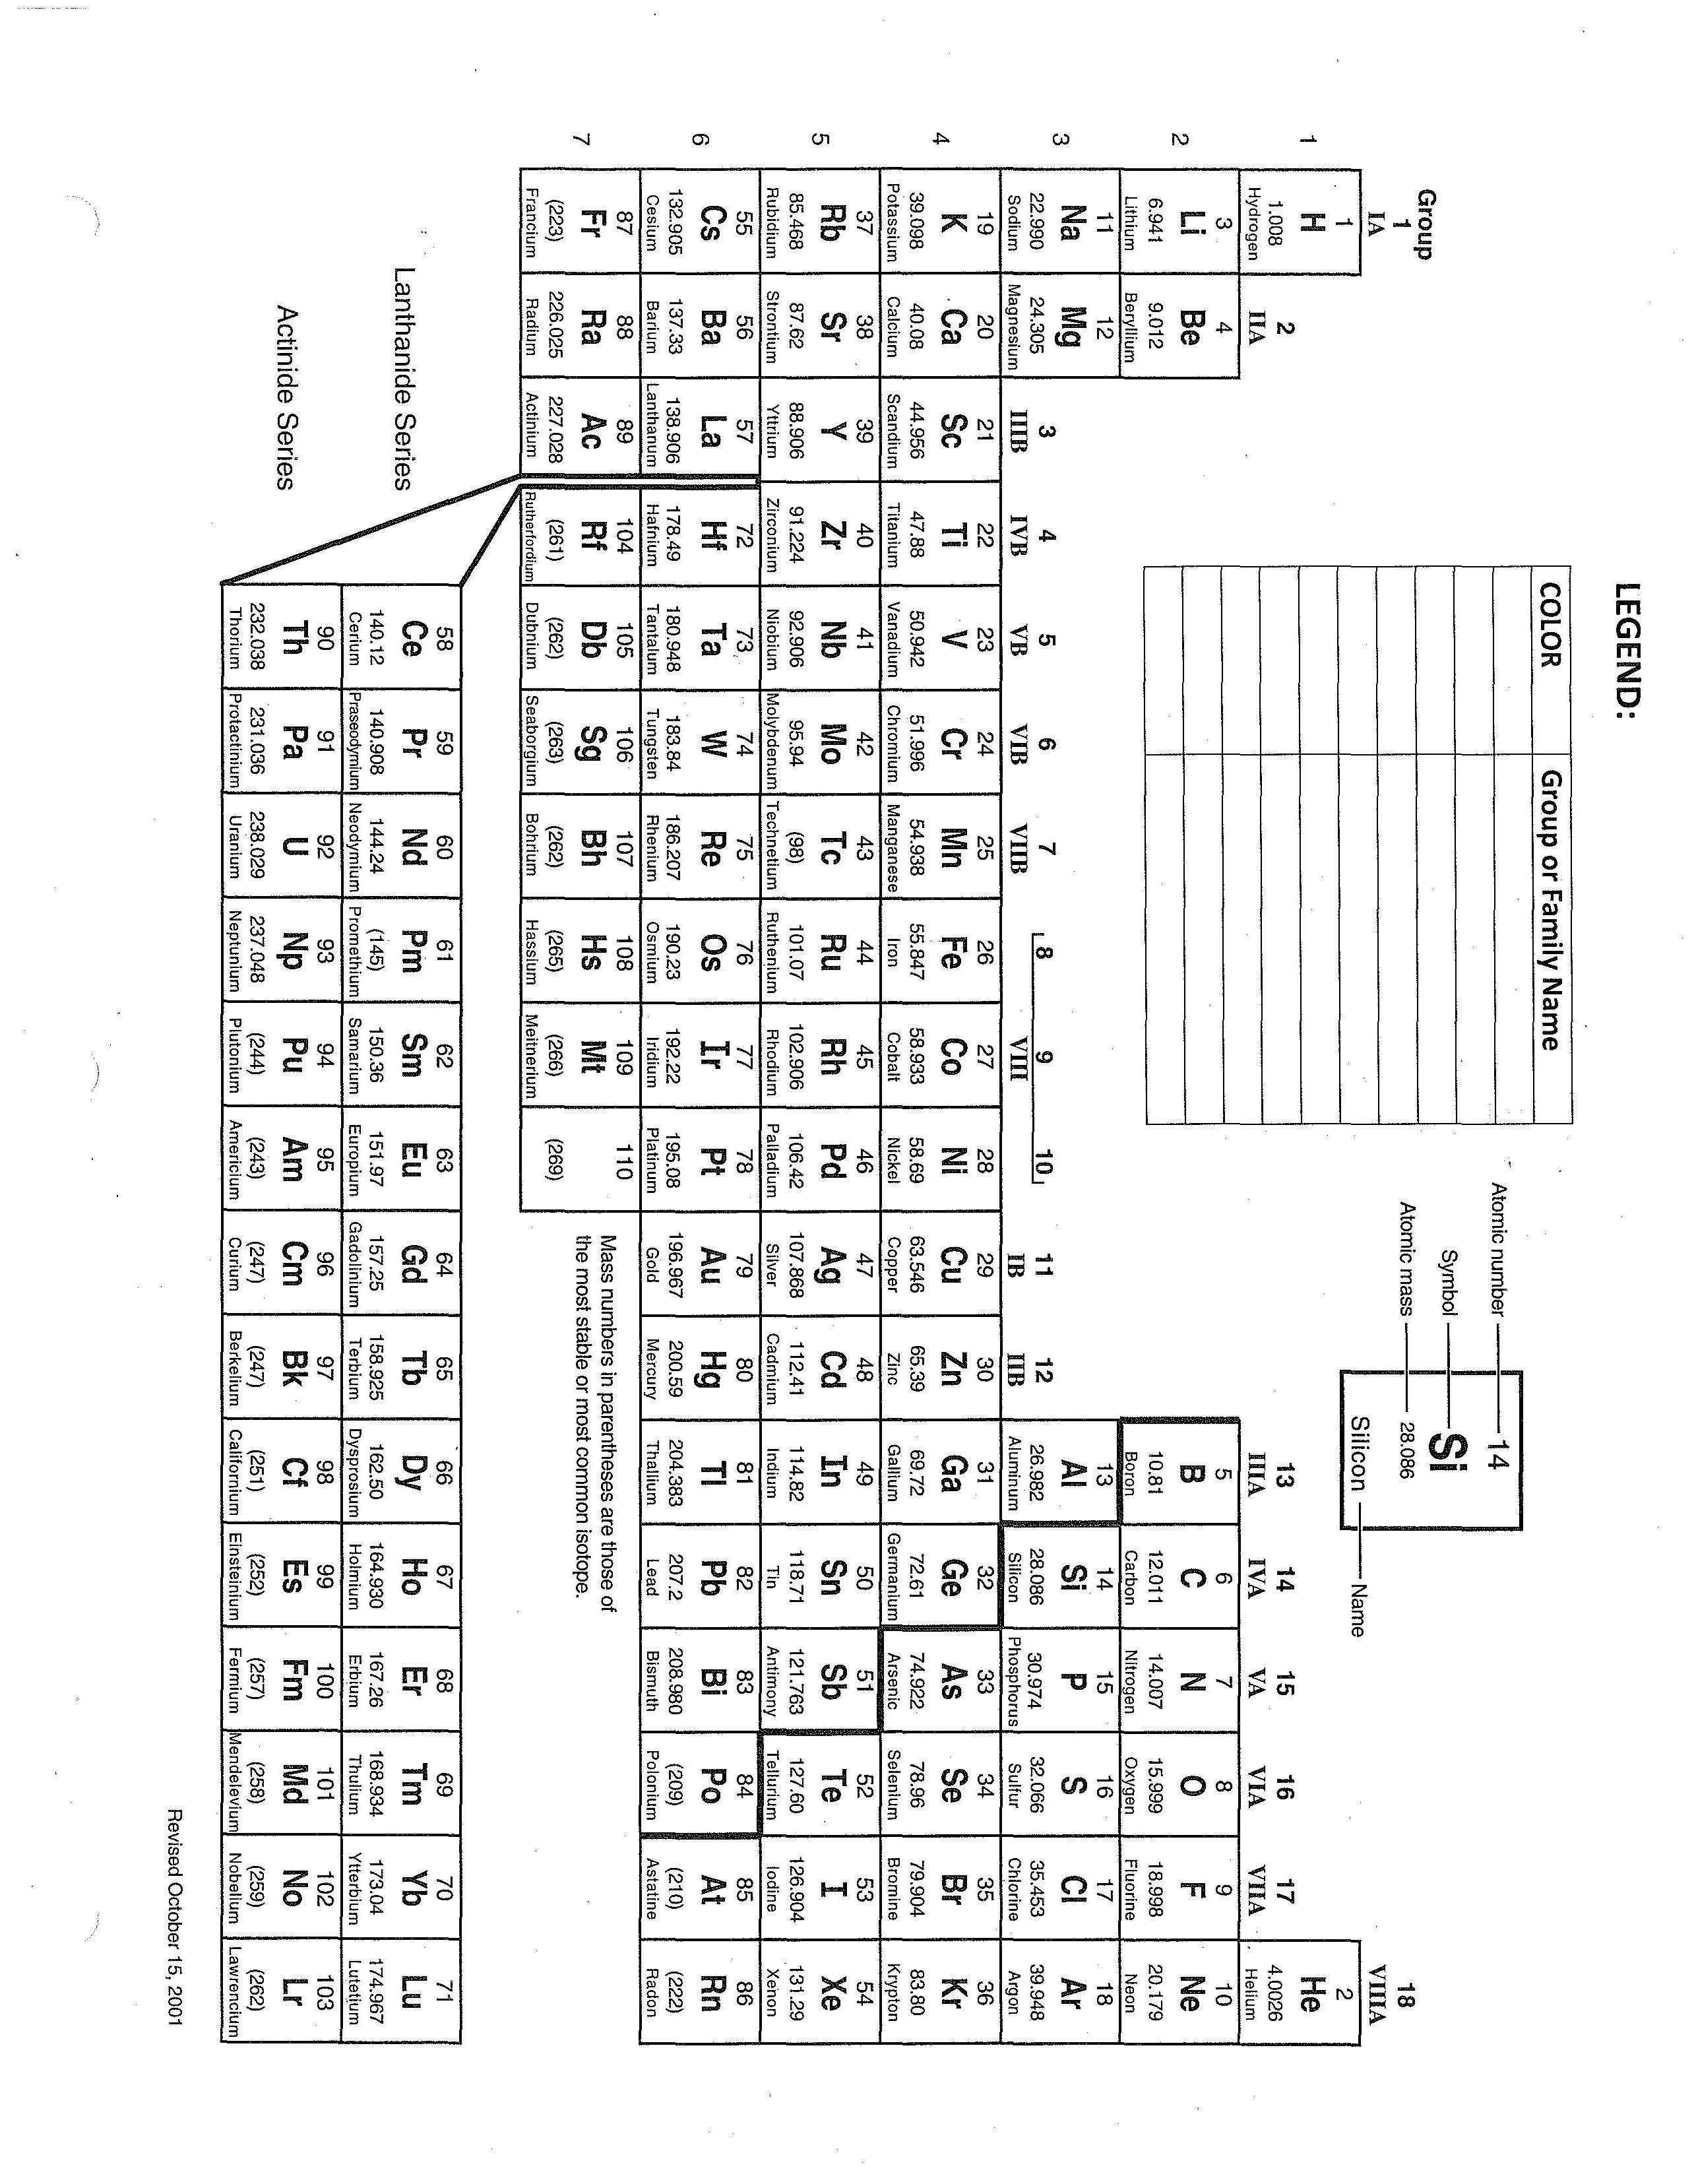Periodic Trends Plot the data in the table below in two separate graphs:
a: first ionization energy vs. increasing atomic number b: Atomic radius vs. increasing atomic number
Element | Atomic Number | Atomic Radius (nm) | First Ionization Energy (kJ/mol)
hydrogen | 1 | 0.037 | 1312
helium | 2 | 0.05 | 2372
lithium | 3 | 0.152 | 519
beryllium | 4 | 0.111 | 900
boron | 5 | 0.088 | 799
carbon | 6 | 0.077 | 1088
nitrogen | 7 | 0.070 | 1406
oxygen | 8 | 0.066 | 1314
fluorine | 9 | 0.064 | 1682
neon | 10 | 0.070 | 2080
sodium | 11 | 0.186 | 498
magnesium | 12 | 0.160 | 736
aluminum | 13 | 0.143 | 577
silicon | 14 | 0.117 | 787
phosphorus | 15 | 0.110 | 1063
sulfur | 16 | 0.104 | 1000
chlorine | 17 | 0.099 | 1255
argon | 18 | 0.094 | 1519
potassium | 19 | 0.231 | 418
calcium | 20 | 0.197 | 590

II. Answer Questions using graphs.
- Moving across the period, what happens to the size of the radius of the atom as the atomic number increases?
- What happens to the size of the radius of the atom as you go down the family?
- Moving across the period, what happens to the ionization energy?
- Moving down a family, what happens to the ionization energy?
II. Drawing Conclusions.
- What properties of the elements relate to their atomic #
- Why does the atomic radius’s size change across the period?
- What does the atomic radius’s size change going down the family?
- Why does the ionization energy change for each element across the period?
- Why does the ionization energy change for each element down the family?
- What element in period 2 has the smallest radius?
- What element in Group IIA has the largest radius?
- What element in period 2 has the highest ionization energy?
- What element in Group I A has the highest ionization energy?
- What is the most active nonmetal?
- What is the most active metal?

Graphing Periodic Trends
1. Plot the data in the table below in two separate graphs:
2. Graph #1: First ionization energy vs. Increasing atomic number
3. Graph #2: Atomic radius vs. Increasing atomic number

Specific Instructions:
1. Make a line graph. Connect dots.
2. Place atomic # on X – axis, the other variable on Y- axis.
3. Label individual data points with element symbol.
4. Answer questions using graphs.

Periodic Table of Un-REAL Elements
Directions: Place the elements in their proper position on the periodic table. To make this more challenging, I have not included their identities. Instead of the usual chemical symbol, each element is represented by a code letter. Some clues to the element’s identity are listed below. In addition, the elements fall into these families / groups.
JKQ, WNVG, IAL, EPFZ, YBR, ODS, CXU, THM
Place each code letter in its proper space in the table below. Indicate the actual chemical symbol that corresponds to each letter. Clue 1 U and J are alkali metals. J has more energy levels

V is an inert gas.
E is an alkali metal
U is a halogen
D is in family VA
J is an alkaline earth metal
T is in Family VI A
R has one les proton than A
A has six protons in its nucleus
R has an atomic number one more than J
O has an atomic number one more than A
S has 8 more protons in its nucleus than D
F has only one proton in each atom
Y has atoms that are larger than the atoms of B
I has the largest atomic number in its group
T is found in the fourth period
C has atoms that are larger than those of U, but smaller than those of X
V has one more proton in its nucleus than U
H has the smallest atomic number in its family
G has two protons in each atom
N is a third period element
Q has an atomic mass greater than that of J and less than that of K
E has an atomic number less than that of Z, but greater than that of J
Z has more protons than other elements in its family
U is found in the second period.

IA VIIIA

IIA IIIA IVA VA VIA VIIA
Fictitious symbols are used for the first 18 elements in the periodic table. Use the clues below to write the fictitious symbol in the appropriate spot on the periodic table provided. Symbols for real elements do not represent those elements. HINT: you do not have to complete each clue in order.
_________________________________________________________________________________________________________________________________________________

Review Questions:
- Define valence electron.
- Define ion. (What do you call a positive ion? Negative ion?)
- Where are nonmetals found on PT? Where are metals found on the PT?
- Nonmetals will form (positive/negative) ions?
- Metals will form (positive/negative) ions?
- Metals (lose/gain) e⁻? Nonmetals (lose/gain) e⁻?
- Which group/family has a full outer shell?
- How many e- are classified as a full outer energy level?
- Define Family. Define Period.
- Identify all parts of the PT?
Transition metals Noble gases Metals Nonmetals Metalloids
Alkali Metals Alkaline Earth Metals Halogens Rare Earth Metals (lanthanide /Actinides)
11)Define and Identify the trends on the periodic table regarding the following: Electronegativity (en) Atomic Radii Ionization Energy
- Differentiate between metals & nonmetals.
- What is the significance of the halogens?
- Determine ion charges of A group elements (s and p orbitals) by the family number.
- Discuss 2 differences between Mendeleev’s Periodic Table & the modern Periodic Table.
- How do you determine the number of valence electrons an atom has?
- Give examples of properties seen in a metalloid.
- What is the purpose of the stair steps on the periodic table?
- How may valence electrons are in the following:
F Ne Na Pb Pb²⁺ S S²⁻
- What happens to the distance between the nucleus and outermost electrons going down a chemical family?
- What happens to the ionization energy going down a family?
- What happens to the distance between the nucleus and outermost electrons going left to right across a period?
- What happens to the charge going across the period?
- What happens to ionization energy going across the period?
- Which of the following pairs should have a greater ionization energy: Br or Cl F or Ne Rb or I
Electron Configuration Practice Worksheet
Write the unabbreviated electron configurations of the following elements:
1. Sodium 2. iron 3. bromine 4. Barium 5. neptunium
Write the abbreviated(Noble Gas) electron configurations of the following elements:
6. cobalt 7. Silver 8. Tellurium 9. Radium10. lawrencium
Determine what elements are denoted by the following electron configurations:
- 1s²2s²2p⁶3s²3p⁴
- 1s²2s²2p⁶3s²3p⁶4s²3d¹⁰4p⁶5s¹
- [Kr] 5s²4d¹⁰5p³
- [Xe] 6s²4f¹⁴5d⁶
- [Rn] 7s²5f¹¹
Determine which of the following electron configurations are not valid based on Aufbau:
- 1s²2s²2p⁶3s²3p⁶4s²4d¹⁰4p⁵
- 1s²2s²2p⁶3s³3d⁵
- [Ra] 7s²5f⁸ _
- [Kr] 5s²4d¹⁰5p⁵
- [Xe]

Electron Cloud/ Flame Test Lab
Background: Certain atoms will emit a characteristic light specific for that particular atom. Exciting the atom, using the heat from the Bunsen burner flame, will allow this light to be seen with the naked eye. In this lab you will place certain elements within the flame and a bright color will flash momentarily. This flash of colored light signals the energy exchange happening in the energy levels of the element. When a sample is added to the flame, energy is added to the electrons. This added energy is emitted when the excited electrons in the atom gives off light and falls back to lower shells. The light emitted possesses wavelengths and colors, depending on the amount of energy the atoms absorbed. You would expect that one type of atom would emit one type of light. But it doesn’t quite work that way because there are billions of atoms being excited and they produce billions of excitations and emissions. Not all of the atoms receive the same amount of energy, thus the excited electrons will travel to different energy levels. The color produced by the heated elements is actually a series of discrete emission lines. (See notes for example diagram) Each emission describes on quantum path that an electron can take after it absorbs energy from the flame. Each element has a unique set of emission lines because each element’s electrons have a unique quantized distribution around the nucleus. In this experiment you will use a spectrometer to measure the light emission produced and your own visual sense of observation to determine the colors produced.
Purpose: To determine how certain metal ions may be identified by the color they impart to a flame.
Procedure:
Preparing the computer:
- Use the USB cable to connect the spectrometer to your computer. Connect the fiber optic cable to the spectrometer.
- Open Logger pro  , found on the desktop of the computer.
- Prepare the spectrometer to measure light emission by:
  - EXPERIMENT----
  - EXPERIMENT ---CHANGE UNITS--- SPECTROMETER:1--- INTENSITY
  - EXPERIMENT --- SET UP SENSORS----SPECTROMETER:1
  - SAMPLE TIME---90ms-----SAMPLESTO AVERAGE----1
  - CLOSE (lower right hand corner of this window)
Preparing for the Flame TEST:
- one person to place the chemical in the flame.
- One person to operate the computer
- One person holding the fiber optic cable.
1. Light your Bunsen burner and adjust the air valves so that the proper flame is produced.
2. Fill a beaker half full of tap water to discard the sticks into after testing.
3. Click the COLLECT (GREEN BUTTON) in the upper right hand corner of the menu bar. The spectrometer is now collecting.
4. Hold the red tip of the fiber optic cable near the flame.
5. Obtain a small amount of the 1st solid substance on the end of the soaked wooden splint (as directed by your teacher)
6. Place the chemical on the stick into the proper part of the flame of the Bunsen burner flame.
7. When you are satisfied that you have obtained the proper spectral lines, chose STOP (red button) the computer will freeze the spectral lines for you to obtain the values.
8. Record the value of the highest peak in nanometers in the wavelength column of the data table.
9. Observe the color produced and record results in data table.
10. Repeat steps 1-8 for the rest of the solid substances using separate wooden splints for each substance.
11. Discard the wooden splints from the waste beaker in the trash and wash out the beaker.

Calculations:
Part 1 Calculating frequency
v =c
λ
*wavelength has to be in meters. 1 nm= 1x10⁻⁹ m

v = frequency (Hertz/sec) (number of waves per sec)
c = speed of light = 3 x 10⁸ meter/sec
λ = wavelength = meters

Part II Calculating Energy:
E = hv
Photoelectric effect: (see web resource) electrons emitted from the surface of a metal when light shines on the metal. There is a specific minimum amount of radiation / light required to knock loose electrons. (quantum)
Formula for calculating the amount of energy in a particular photon:
E = hv
E = energy = Joules
h = Planck’s constant = 6.626 x 10 ⁻³⁴ J . s
v = frequency = Hertz (Hertz / sec)

The Mendeleev Lab of 1869
Problem: Use your knowledge of the periodic table to determine the identity of each of the nine unknown elements in this activity. The unknown elements are from the following groups in the periodic table. Each group listed below contains at least one unknown. 1 2 11 13 14 17 18
- None of the known elements serve as one of the nine unknown elements.
- No radioactive elements are used during this experiment. The relevant radioactive elements include Fr, Ra, At, and Rn.
- You may not use your textbook or other reference materials. You have been provided with enough information to determine each of the unknown elements.
Procedure:
- Inspect the properties of the known elements.
- Arrange the cards of the known elements in a crude representation of the periodic table.
- Once the known elements are in place, inspect the properties of the unknowns to see where their properties would best "fit" the trends of the elements of each group.
- In your data table, assign the proper element name to each of the unknowns. Record the symbol for each of the "unknowns" in your data table.
Data Table:
Be sure to make your data table so that you have enough space for all your unknown elements.
Conclusion:
Summarize your group's reasoning for assignment of each unknown. Explain in a few sentences exactly how you predicted the identity of the unknowns.

Name ________________________________________________ date ______________________ period _______Estimated Test date ______________

Periodic Table and Electron Arrangement
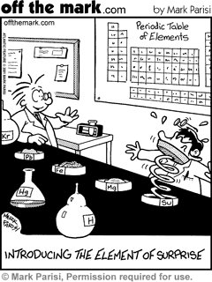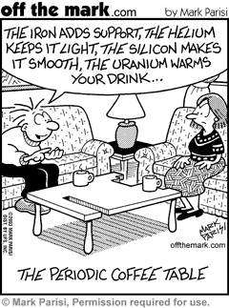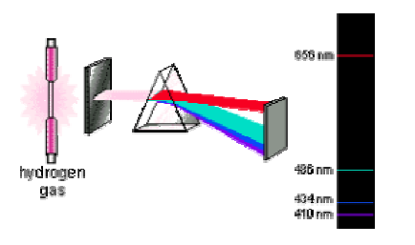

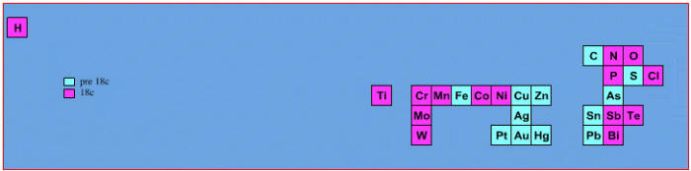 | Elements known before 1800, plus those discovered between 1800 and 1899:
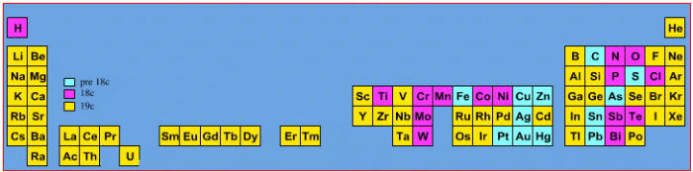 | Elements known before 1900, plus those discovered between 1900 and 2005:
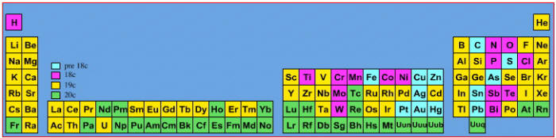 | Elements known before 1900, plus those discovered between 1900 and 2005:

Li  Physical State solid  Density 0.534 g/cm³  Hardness soft, claylike  Conductivity good  Solubility (H₂O) reacts with water  Melting Point 180ºC  Color silver | Cl₂  Physical State gas  Density 0.00321 g/cm³  Hardness none  Conductivity very poor  Solubility (H₂O) slight  Melting Point -101ºC  Color greenish yellow

Ag  Physical State solid  Density 10.50 g/cm³  Hardness somewhat soft  Conductivity excellent  Solubility (H₂O) none  Melting Point 961ºC  Color silver | He  Physical State gas  Density 0.00018 g/cm³  Hardness none  Conductivity very poor  Solubility (H₂O) none  Melting Point -272ºC  Color colorless

Cu  Physical State solid  Density 8.96 g/cm³  Hardness somewhat soft  Conductivity excellent  Solubility (H₂O) none  Melting Point 1803ºC  Color | Na  Physical State solid  Density 0.971 g/cm³  Hardness soft, claylike  Conductivity good  Solubility (H₂O) reacts rapidly  Melting Point 98ºC  Color silver

C  Physical State solid  Density 2.10 g/cm³  Hardness soft, yet brittle  Conductivity good  Solubility (H₂O) negligible  Melting Point 3550ºC  Color black | Ca  Physical State solid  Density 1.57 g/cm³  Hardness medium  Conductivity good  Solubility (H₂O) reacts  Melting Point 845ºC  Color silvery white

Unknown #8  Physical State solid  Density 1.74 g/cm³  Hardness medium  Conductivity good  Solubility (H₂O) reacts slowly  Melting Point 651ºC  Color silvery white | Unknown #9  Physical State solid  Density 11.85 g/cm³  Hardness very soft  Conductivity medium  Solubility (H₂O) none  Melting Point 303ºC  Color silvery white

Be  Physical State solid  Density 1.85 g/cm³  Hardness brittle  Conductivity excellent  Solubility (H₂O) none  Melting Point 1287ºC  Color gray | Sn  Physical State solid  Density 7.31 g/cm³  Hardness somewhat soft  Conductivity good  Solubility (H₂O) none  Melting Point 232ºC  Color silver

Ne  Physical State gas  Density 0.00090 g/cm³  Hardness none  Conductivity very poor  Solubility (H₂O) none  Melting Point -249ºC  Color colorless | Br₂  Physical State gas  Density 3.12 g/cm³  Hardness none  Conductivity very poor  Solubility (H₂O) negligible  Melting Point -7.2ºC  Color reddish brown

K  Physical State solid  Density 0.86 g/cm³  Hardness soft, claylike  Conductivity good  Solubility (H₂O) reacts rapidly  Melting Point 63ºC  Color silver | Ba  Physical State solid  Density 3.6 g/cm³  Hardness soft  Conductivity good  Solubility (H₂O) reacts strongly  Melting Point 710ºC  Color silvery white

Xe  Physical State gas  Density 0.00585 g/cm³  Hardness none  Conductivity very poor  Solubility (H₂O) none  Melting Point -119.9ºC  Color colorless | In  Physical State solid  Density 7.31 g/cm³  Hardness very soft  Conductivity medium  Solubility (H₂O) none  Melting Point 157ºC  Color silvery white

I₂  Physical State solid  Density 4.93 g/cm³  Hardness soft  Conductivity very poor  Solubility (H₂O) negligible  Melting Point 113.5ºC  Color bluish-black | Pb  Physical State solid  Density 11.35 g/cm³  Hardness somewhat soft  Conductivity poor  Solubility (H₂O) none  Melting Point 327.5ºC  Color gray
Ar  Physical State gas  Density 0.00178 g/cm³  Hardness none  Conductivity very poor  Solubility (H₂O) none  Melting Point -189.2ºC  Color colorless | Ga  Physical State solid  Density 5.904 g/cm³  Hardness soft  Conductivity medium  Solubility (H₂O) none  Melting Point 30ºC  Color silvery

Cs  Physical State solid  Density 1.87 g/cm³  Hardness soft  Conductivity good  Solubility (H₂O) reacts violently  Melting Point 29ºC  Color silvery white | Unknown #1  Physical State solid  Density 2.33 g/cm³  Hardness brittle  Conductivity intermediate  Solubility (H₂O) none  Melting Point 1410ºC  Color gray

Unknown #2  Physical State gas  Density 0.00170 g/cm³  Hardness none  Conductivity very poor  Solubility (H₂O) slight  Melting Point -219.6ºC  Color pale yellow | Unknown #3  Physical State solid  Density 1.53 g/cm³  Hardness soft  Conductivity good  Solubility (H₂O) reacts violently  Melting Point 39ºC  Color silvery white

Unknown #4  Physical State gas  Density 0.00374 g/cm³  Hardness none  Conductivity very poor  Solubility (H₂O) none  Melting Point -156.6ºC  Color colorless | Unknown #5  Physical State solid  Density 19.3 g/cm³  Hardness soft  Conductivity excellent  Solubility (H₂O) none  Melting Point 1064ºC  Color gold

Unknown #6  Physical State solid  Density 2.54 g/cm³  Hardness somewhat soft  Conductivity good  Solubility (H₂O) reacts rapidly  Melting Point 769ºC  Color silvery white | Unknown #7  Physical State solid  Density 5.32 g/cm³  Hardness fairly brittle  Conductivity fair to poor  Solubility (H₂O) none  Melting Point 937ºC  Color gray

