Name ____________________________________________________ date ________ Period ________

Estimated TEST date _____________________ If found, please return to Mrs. Paul (J204)

Stoichiometry
(Greek: to measure elements)
(The study of the relationships of reactants and products in a balanced chemical equation)

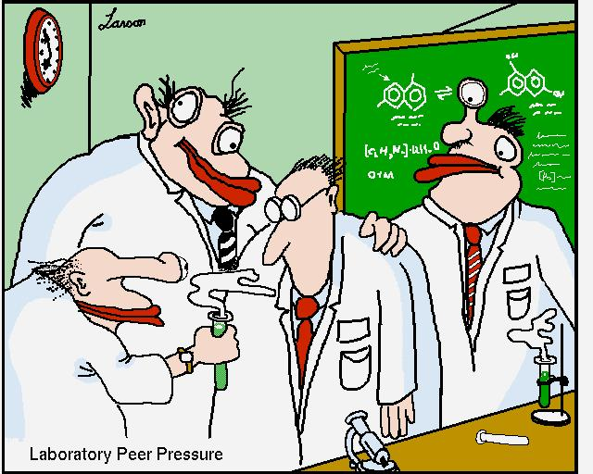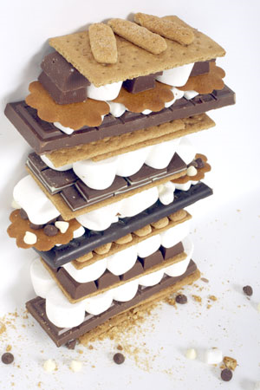
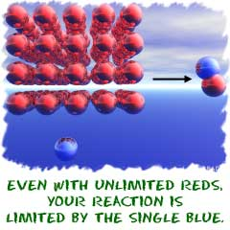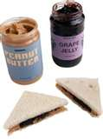


Part 1: Types of problems: CLASS DISCUSSION.

Reaction: Aluminum oxide decomposes

___________________________________________________ → __________________________________________________

A Mole-mole
- How many moles of Al could be produced from 13.0 moles of Al₂O₃?

- How many moles of O₂ would be produced from 20.2 moles of Al₂O₃?

- How many moles of Al₂O₃ would be required to produce 5 moles of Al?

- How many moles of Al₂O₃ would be required to produce 63 moles of O₂?

B. Mole-mass

- How many grams of Al would be produced from 8 moles of Al₂O₃?

- How many grams of O₂ would be produced from 22 moles of Al₂O₃?

- How many grams of Al₂O₃ would be needed to produce 3 moles of O₂?

- How many grams of Al₂O₃ would be needed to produce 72 moles of Al?

Reaction: Aluminum oxide decomposes

___________________________________________________ → __________________________________________________

C. Mass-mole

- How many moles of Al would be produced from 890 grams of Al₂O₃?

- How many moles of O₂ would be produced from .95 grams of Al₂O₃?

- How many moles of Al₂O₃ would be needed to produce 524 grams of O₂?

- How many moles of Al₂O₃ would be needed to produce 72 grams of Al?

D. Mass-mass
- How many grams of Al would be produced from 76 grams of Al₂O₃?

- How many grams of O2 would be produced from 641 grams of Al₂O₃?

- How many grams of Al₂O₃ would be needed to produce 4.75 grams of O2?

- How many grams of Al₂O₃ would be needed to produce 1258 grams of Al?

Part 2: “Table TALK” PROBLEM SOLVING:
SOLVE THE PROBLEMS BELOW ON THE DESK TABLE TOPS AS A GROUP USING DIMENSIONAL ANAYLSIS. ONCE YOU HAVE AGREED THAT YOUR ANSWER IS REASONBLE AND CORRECT, TRANSFER THE WORK TO THE Spiral. The first reaction is written for you , however it will need to be balanced before solving the stoichiometric problems.

CO₂ + H₂O -----→ C₆H₁₂O₆ + O₂

- How many moles of glucose could be produced if 27 moles of water react with carbon dioxide?
- How many moles of CO2 would be required to produce 18 moles of O₂?
- If 500 moles of glucose were produced how many moles of carbon dioxide for the reaction to go to completion?

In a spacecraft, the CO₂ exhaled by astronauts can be removed with lithium hydroxide, which produces Lithium carbonate and water. Stoichiometric calculations must be carefully made to ensure that the proper amount of lithium hydroxide is brought for the entire trip in space.

____________________________________________ → _______________________________________

- How many grams of LiOH would be needed to remove 20 moles of CO₂?
- If Susie exhales 1 mole of CO₂ per hour, how many grams of LiOH should be needed to remove her 1-day’s worth of CO₂?
- Based on this amount as an average of the crew members, how many grams of lithium hydroxide for a crew of 5 for 3 days?

Laughing gas is sometimes used as an anesthetic in dental work. It is produced when ammonium nitrate is decomposed into dinitrogen monoxide and water.

____________________________________________ → _______________________________________

- If 578 grams of N₂O were needed, how many moles of NH₄NO₃ would be required to react completely?

- If 3 grams of water would be produced for the following reaction, how many moles of N₂O would be produced along with this reaction?

Joseph Priestly discovered oxygen in 1774 when he was decomposing mercury II oxide.

____________________________________________ → _______________________________________

- How many grams of mercury would be produced from 671 grams of HgO?

10. If 243 grams of O₂ were produced in the above reaction, how many grams would be required of HgO for this reaction to go to completion?

Part 3: More Practice: (Homework: SOLVE THE PROBLEMS BELOW IN YOUR SPRIAL NOTEBOOK)

1. Nitrogen and hydrogen react to form ammonia gas according to the following
equation.
___N2 + ___H2 →  ___NH3
a. If 56.0 grams of nitrogen are used up by the reaction, how many grams of
ammonia will be produced?
b. How many grams of hydrogen must react if the reaction needs to produce
63.5 grams of ammonia?
2. Aluminum metal reacts with zinc chloride to produce zinc metal and aluminum
chloride.
___Al + ___ZnCl2 → ___Zn + ___AlCl3
a. A mass of 45.0 grams of aluminum will react with how many grams of zinc
chloride?
b. What mass of aluminum chloride will be produced if 22.6 grams of zinc
chloride are used up in the reaction?
3. For the reaction whose balanced equation is as follows, find the number of
grams of I2 that will be formed when 300.0 g of bromine react.
2 KI + Br2 → 2 KBr + I2
4. For the reaction whose balanced equation is as follows, find the number of
grams of sodium that must react to produce 42.0 grams of sodium oxide.
4 Na + O2 →→2 Na2O
5. For the reaction whose balanced equation is as follows, find how many grams of
zinc phosphate will be produced by the reaction of 5.00 grams of ammonium
phosphate.
3 ZnCl2 + 2 (NH4)3PO4 →→Zn3(PO4)2 + 6 NH4Cl

PART 4: Stoichiometry Problems With a Twist !
1. When mercury (II) oxide is heated, it decomposes into mercury and oxygen gas
according to the following BALANCED equation.
2 HgO → 2 Hg + O2
a. Given that the density of oxygen is 1.439 g/L, how many liters of oxygen gas
can be produced if 2.0 moles of mercury (II) oxide are heated?
b. How many molecules of oxygen gas are produced if 25.0 g of mercury (II)
oxide are heated?
NaN3 + AgNO3 → AgN3 + NaNO3
2. How many molecules of sodium nitrate are produced when 20.0 g of sodium
azide, NaN3, react according to the following BALANCED equation?
***3. A compound contains only carbon, hydrogen, and oxygen. Combustion of 10.68 mg of the compound yields 16.01 mg carbon dioxide and 4.37 mg water. The molar mass of the compound is 176.1 g/mol. What are the empirical and molecular formulas of the compound?

PART 4: S’more Lab

Purpose: To measure and build a S’more to illustrate and calculate the concept of Stoichiometry using known food items.

Procedure Part I:
- Place a clean weighing boat on the electronic balance and tare out the mass to 0.000g.
- Place one graham cracker in the weighing boat and record the mass to 0.000 g in the table below.
- Repeat these steps for 1 chocolate square and 1 marshmallow. Making sure to record the masses for each to 0.000g.
- Using the provided materials at your table and the “S’more Reaction” below, determine how many s’mores you will be able to make. (Remember: do not place food items directly on the lab tables, use the paper plate)
- Answer the questions below, using the “S’MOLE Ratios” given to you by your teacher.
- Once you and your partners have completed the work below, show your teacher your answers. You may not proceed to the next step until you complete the work below!

Calculations:
__Graham Crackers + __Chocolate square + __Marshmallow → __S’more

1 graham cracker= __________g x _____(# of crackers) =total mass of crackers in s’more _____g

1 chocolate square= _______ g x _____(# of chocolate squares) total mass of chocolate in s’more _____g

1 marshmallow = ________ g x ______(# of marshmallows) total mass of marshmallows in s’more _____g

total = __________________ g = 1 mole of s’more

1. 1 mole of s’more= __________________g

2. What is the s’more ratio?

3. If you have ____________ g of graham crackers how many moles of s’mores can you make?
(your total from the box)

4. If you have ____________ g of chocolate squares how many moles of s’mores can you make?
(your total amount of chocolate)

5. If you have ____________ g of marshmallows how many moles of s’mores can you make?
(your total from the bag)

6. Which item limited the number of s’mores you could make?

5. How many grams of each item would you need to make 8 moles of smores? ( use your numbers for calculations)

g. PROCEED TO PART II

Procedures Part II:
- Obtain and light the provided Bunsen Burner. ( reserved for food labs only)
- Adjust your Bunsen Burner to acquire a flame that exhibits complete combustion. (Hint: you will know by the color…..)
- Place one marshmallow on the metal stick and roast it in the flame to your desired consistency. Warning: Marshmallow will be very HOT!
- Quickly squeeze the roasted marshmallow between 2 graham crackers with 2 chocolate squares. This will melt the chocolate to make the perfect S’more.
- You may eat your S’more if you choose. ☺

PART 5: Limiting Reactants Activity: “CANDY COMPOUNDS”

Purpose: Using a variety of known candies masses , determine the candy that will limit the formation of “Pepperscotch”, “Tootsiebear”, “Skitburst” and “CarmelCorn” in each part of the activity. Complete the following using the candy provided in the ziplock bags. Do not open the bags of candy.

1. One butterscotch reacts with one peppermint to form a pepperscotch according to the following BALANCED equation.
1 Bs + 1 P → 1 PS
- Use the candy in the bag to illustrate this reaction and answer the following questions.
- How many “pepperscotches” can be formed?
Work:

- What is the limiting reactant? ____________________
Work:

- What reactant is in excess? _________________ How much of it is left over?_______________________
Work:

e. Use the balanced equation to answer the following question. One butterscotch has a mass of 5.0 grams and one peppermint has a mass of 4.0 grams. How many pepperscotches can be made with 50.0 grams of
butterscotch and 48.0 grams of peppermints?

2. One tootsie roll reacts with four gummy bears to form a tootsie bear according to the following BALANCED equation.
1 Tr + 4 Gb → 1 TB
a. How many “tootsiebears” can be formed?
Work:

- What is the limiting reactant? ____________________
Work:

- What reactant is in excess? _________________ How much of it is left over?_______________________
Work:

d. Use the balanced equation to answer the following question. One tootsie roll has a mass of 2.0 grams and one gummy bear has a mass of 1.5 g. How many tootsie bears can be made with 12.5 grams of tootsie rolls and 15.0 grams of gummy bears?
Work:

3. Two starburst fruit react with six skittles to from a “skitburst” according to the following BALANCED equation.
2 Sb + 6 Sk → 1 SB
a. How many “skitbursts” can be formed?
Work:

- What is the limiting reactant? ____________________
Work:

- What reactant is in excess? _________________ How much of it is left over?_______________________
Work:

d. Use the balanced equation to answer the following question. One starburst has a mass of 5.0 grams and one skittle has a mass of 1.0 gram. How many skitburts can be made from 40.0 grams of starburst and 26.0 grams of skittles?

4. One caramel reacts with three candy corn to form a caramel corn according to the following BALANCED equation.
1 C + 3 Cc → 1 CC
a. How many “caramelcorns” can be formed?
Work:

- What is the limiting reactant? ____________________
Work:
- What reactant is in excess? _________________ How much of it is left over?_______________________
Work:

d. Use the balanced equation to answer the following question. One candy corn has a mass of 1.5 grams and one caramel has a mass of 11.0 g. How many caramel corns can be made with 60.0 grams of candy corn and 66.0 grams of caramel?

Part 6: Limiting Reactants Practice
Work all problems in your spiral

1. Given: 65 g Sodium hydroxide reacts with 5.6 g Hydro-chloric Acid.
1. What is the limiting reactant?
2. What is the reactant in excess? By how much in grams?
3. How much in grams of each product will be made?
4. How much more in grams do you need of the limiting reactant?

2. Given: 3.75 grams of calcium oxide was mixed with 89 grams of water to produce calcium hydroxide solution.
1. What is the limiting reactant?
2. What is the reactant in excess? By how much in grams?
3. How much in grams of each product will be made?
4. How much more in grams do you need of the limiting reactant?

3. Given: 568 g Iron II chloride reacts with 64 g potassium sulfate….

1. What is the limiting reactant?
2. What is the reactant in excess? By how much in grams?
3. How much in grams of each product will be made?
4. How much more in grams do you need of the limiting reactant?

4. Given: Silicon dioxide (quartz) is usually quite un-reactive, but reacts readily with hydrofluoric acid. Write and balance the reaction and answer the following limiting reactant questions.
If 2.0 mol of hydrofluoric acid are exposed to 4.5 mol of silicon dioxide, which will limit the reaction.

5. Given Zinc and sulfur react to form zinc sulfide. Write and balance the reaction and answer the following limiting reactant questions.
  - If 2.0 mol of zinc are heated with 1.00 mol of Sulfur, which substance will limit the reaction?
  - How many moles of the excess reactant remain?
  - How many moles of the product will be allowed to form?

6. Given: Chlorobenzene (C₆H₅Cl) is used in the production of many important chemicals such as aspirin, dyes and disinfectants. One industrial method of preparing this compound is to react benzene (C₆H₆) with chlorine with hydrochloric acid as a product.
  - When 36.8 g of benzene react with 4.00 grams of Chlorine which reactant will limit the amount of product produced?
  - How many moles of the excess reactant remain?
  - What would the theoretical yield be for the production of Chlorobenzene?

Part 7: Hydrate Lab

As you’ve learned in class, hydrates are chemical compounds, which contain loosely bound water molecules. Because these water molecules are loosely bound, they can be easily removed or replaced.

In this lab your job will be to find the empirical formula of magnesium sulfate hydrate. You will be given five grams of magnesium sulfate hydrate – with this material you may use any laboratory procedures you like to find the empirical formula (pending my approval).

Some things you should keep in mind:
- You will be limited to five grams of the magnesium sulfate hydrate – make sure you don’t waste it!
- Make sure to put all waste in the designated waste container.
- Wear eye protection at all times!

Proper set up of apparatus:

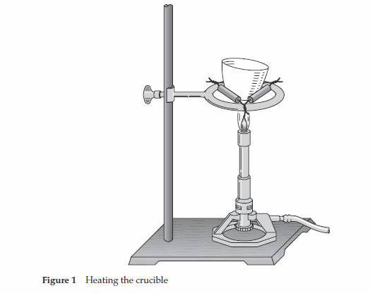

Helpful formulas:

1. % water = mass of water
mass of total sample ^{x 100%} = _____________________ %

2. moles of magnesium sulfate = ____mass of sample without water__ = ____________mol of MgSO4
gram formula mass of MgSO4

3. moles of water = mass of water = ________________ mol of H2O
gram formula mass of water

4. Number of waters of hydration = moles of water
moles of MgSO4 ^{= ___________}

Part 8 :EXPERIMENT – “Mini Rockets”

OBJECTIVES
- Observe the production of H2 and O2 .
- Use the technique of water displacement to collect H2 and O2 gas.
- Relate chemical concepts such as stoichiometry, limiting reagent, activation energy, and thermodynamics to observations of chemical reactions.
- Infer a conclusion from experimental data and evaluate methods.
- Determine the ratio of H₂ and O₂ that produces the greatest “launch”

INTRODUCTION
Hydrogen, H2 , and oxygen, O2 , are two gases that react with each other in a very quick, exothermic (heat-producing) manner. The explosiveness of this reaction is greatest when hydrogen and oxygen are present in just the proper proportion. The reaction is used to power three of the rocket engines that carry the space shuttle into orbit.

In this experiment, you will generate hydrogen and oxygen and collect them using the “water displacement” method. You will test their explosive nature, first separately and then in reactions of different proportions of the two gases. After finding the most powerful reaction combination, you will use this reaction to launch a rocket across the room.

SAFETY
Always wear safety goggles. Recommend apron.
Avoid contact with chemicals. If chemical gets on skin or clothing, notify teacher, wash off at sink.
Call your teacher in the event of a spill. Spills to cleaned up by teacher’s directions.

MATERIALS
• 100 mL beakers (or larger), 2  • Plastic tub  • Piezoelectric sparking element  • Nail launcher  • Forceps  • 1.0 M HCl solution  • 3% H2O2 solution  • Mossy zinc fragment  • Manganese fragment  • Tap water | • Gas collection bulb, calibrated (must make  from disposable pipette)  • Micro O2 generator (must assemble)  - small glass vial  - #0 one-hole stopper  - cut disposable pipette stem  • Micro H2 generator (must assemble)  - small glass vial  - #0 one-hole stopper  - cut disposable pipette stem

PROCEDURE

- Label the two beakers water and spent solution. Be sure both beakers are nearby as you proceed. Fill the beaker labeled water full of water and the petri dish three-fourths full of water.
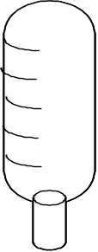
- Make a gas collection bulb – made from a disposable pipette. Cut the stem off of the bulb, leaving about 1 cm of the stem. Mark off the bulb into six equal sections.
- The micro H₂ generator is a small glass vial containing a piece of zinc metal, capped with a one-hole stopper. A thin plastic tube (a cut piece of disposable pipette stem) is inserted into the stopper so that about 1 cm projects up from the stopper (see the diagram at right).
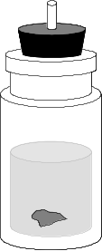
- Remove the stopper of the H₂ generator, and carefully add enough 1.0 M HCl to fill the vial to within 1-2 cm of the top. Replace the stopper and ensure that the bottom of the stopper does not extend into the HCl. If it does then a small amount of acid must be removed. Set the H2 generator in the shallow plastic tub. The purpose of the tub is to catch overflow liquid as gas is collected.
- The micro O2 generator is another vial capped with a stopper and tube. Remove the stopper, and carefully add enough 3% H2O2 to fill the vial to within 1-2 cm of the top. Then add 4 or 5 small pieces of manganese metal to serve as a catalyst. Replace the stopper, ensuring it does not go into the hydrogen peroxide inside. Set the O2 generator in the plastic tub beside the H2 generator.
- Fill the collection bulb completely with tap water from the water beaker using a disposable pipette. The bulb can be inverted and the water will not pour out due to the surface tension of the water across the bulb’s opening.
- To collect hydrogen gas, place the water-filled collection bulb mouth downward over the plastic tube nozzle of the H2 generator. Fill the bulb completely with hydrogen, except for a drop or two of water remaining in the narrow neck. Remove it from the nozzle and place a finger over the mouth of the bulb to prevent the collected gas from escaping.
- Fire the bulb of hydrogen gas off by moving your finger aside and inserting the bulb tip over the nail on the nail launcher. Keep the piezoelectric sparker away from the gas-generating vials. Pull the trigger of the piezoelectric sparker over the bulb and observe. Record the relative loudness of the reaction (on a scale of 1 to 10) in the Data Table.
- To collect oxygen gas, refill the bulb with water, place the bulb mouth downward over the nozzle of the O2 generator, and repeat steps 5 and 6, pop testing the bulb with the piezoelectric sparker. Record the loudness of the reaction (on a scale of 1 to 10) in the Data Table.
- Refill the bulb with water, and begin collecting another bulb of O2 , but when the bulb is about one-sixth full of O2 (with five-sixths water), move the bulb from the O2 generator to the H2 generator, and continue collecting. When the bulb is filled with gas, you will have a combination that is 1 part oxygen and 5 parts hydrogen. Remove the bulb from the nozzle, test it on the nail launcher, and record the relative loudness of the reaction in the Data Table.
- Repeat filling gas collector again, making the switch from the O2 to the H2 generator at different times so that you can test various proportions (2:4, 3:3, 4:2, and 5:1) to complete the data table. Determine the optimum (most explosive) combination.
- If either generator reaction slows down so that it takes more than 1 minute to fill the bulb with gas, lift off the bulb, uncork the vial, and decant the remaining liquid into the spent solution beaker. Refill the vial with fresh solution(s) from the appropriate bottle(s), replace the cap, and resume collecting gas.

Cleanup and Disposal
Clean all apparatus and your lab station. Return equipment to its proper place. Dispose of chemicals and solutions in the containers designated by your teacher. Do not pour any chemicals down the drain or in the trash unless your teacher directs you to do so. Wash your hands thoroughly before you leave the lab and after all work is finished.

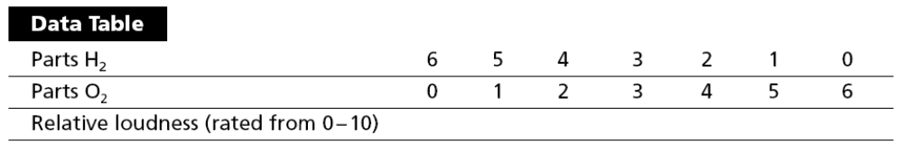

QUESTIONS

What is the purpose of this lab?

- Write a balanced equation for the reaction taking place inside the O₂ generator.

- Write a balanced equation for the reaction taking place inside the H₂ generator.

- Which do you think will be used up first: the Mn in the O₂ generator or the Zn in the H₂ generator? Why?

- What laboratory techniques did you use to help ensure that the gas collecting bulb contained only the desired gas?

- Make a bar graph (on the back of this page) of the relative loudness produced by your pop tests of the mixtures, with the loudness from 0 through 10 on the y-axis and trial 1 through 7 on the x-axis.

- From your observations, state the relative combustibility of pure O₂ and pure H₂.

- Which reaction combinations produced no reaction at all? Explain what happened.

- What proportion of oxygen to hydrogen produced the most explosive reaction? Explain why that combination was the most explosive by referring to the balanced chemical equation for the reaction and the concepts of limiting reagents and maximum yields.

- Why don’t O₂ and H₂ react as soon as they mix in the collection bulb? The individual O₂ and H₂ molecules are certainly colliding with one another.

- What role does the spark play?

